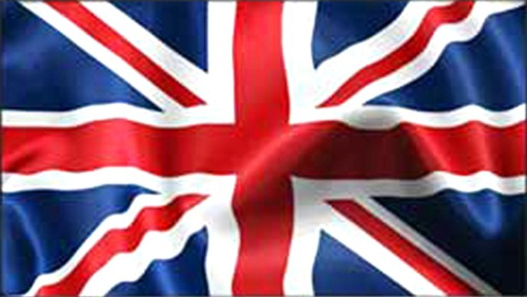

The countries of the United Kingdom are Scotland, Wales, England and Northen Ireland. The capital of Scotland is Edimburgh, the capital of Wales is Cardiff, the capital of England is London and the capital of Northen Ireland is Belfast. London is also the capital of the UK. The flag of the UK is the Union Flag or Union Jack.
BRITISH FOOD TODAY
Roast Beef and fish and chips are traditional British dishes. Pasta and pizza are very popular infact most people buy pizza at supermarket. Chinese and Indian food is very popular too. British people also eat a lot of fast food, which is unhealthy. Health food restaurants are very popular because they sell organic food.
SCHOOL LIFE
British students start secondary school when they’ re 11 or 12. They can leave school when they’ re 16 but most students stay until they are 18. They go to school from Monday to Friday. They start school at 8,30 a.m and finish at 3,30 p.m. They stop for lunch at 12,45 p.m. They have two hours of homework every night. The school year has three terms:
- the autumn term
- the spring term
- the summer term
The summer holidays are about six weeks long. The students have to wear a uniform.
SOCIAL HABITS
People form queues in shops, banks, cinemas and at bus stops. The British have a reputation for being reserved. It’ s illegal to sell cigarettes to anyone under the age of 16. Please, sorry and thank you are used many times in a conversation in the UK. The usual way of addressing someone is using MR/MRS/MISS/MS and their surname. People expect you to cross roads at zebra crossings. The British drive on the left-hand side of the road. The usual British meals are breakfast, lunch, snack, dinner and supper. One of the most common ways to start a conversation in England is to talk about the weather.

