Interpreting resonance maps
I use text analysis software called Crawdad Desktop 2.0 to determine which concepts are cited in any of your posts. This software analyzes your post and determines which words or concepts are the most significant and then generates a concept map or resonance map. The most influential words are shown enclosed in red lines, the next most influential words are shown in enclosed in yellow, and the next most influential words are shown enclosed in white. The colors of the links indicate the frequency of co-occurrence of the connected words. Gray links indicate one co-occurrence, black links indicate two co-occurrences, and blue links indicate three or more co-occurrences. The most influential words tend to be located near the top or the map, and the lower portion of the graph tends to contain less influential words.
Here is part of a map for the part of an initial post on searching the internet:
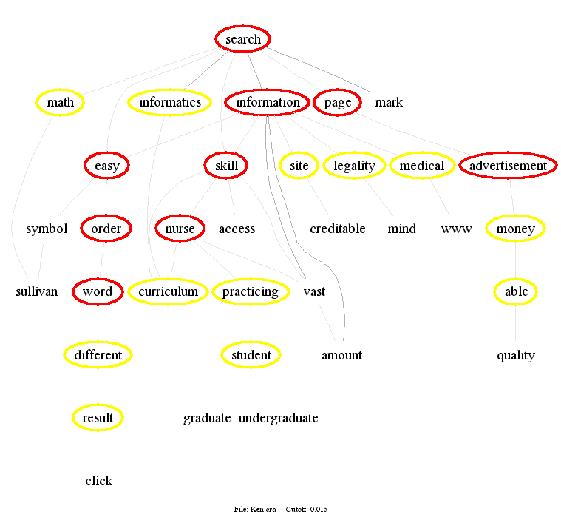

The software will also list the most significant words and word pairs:
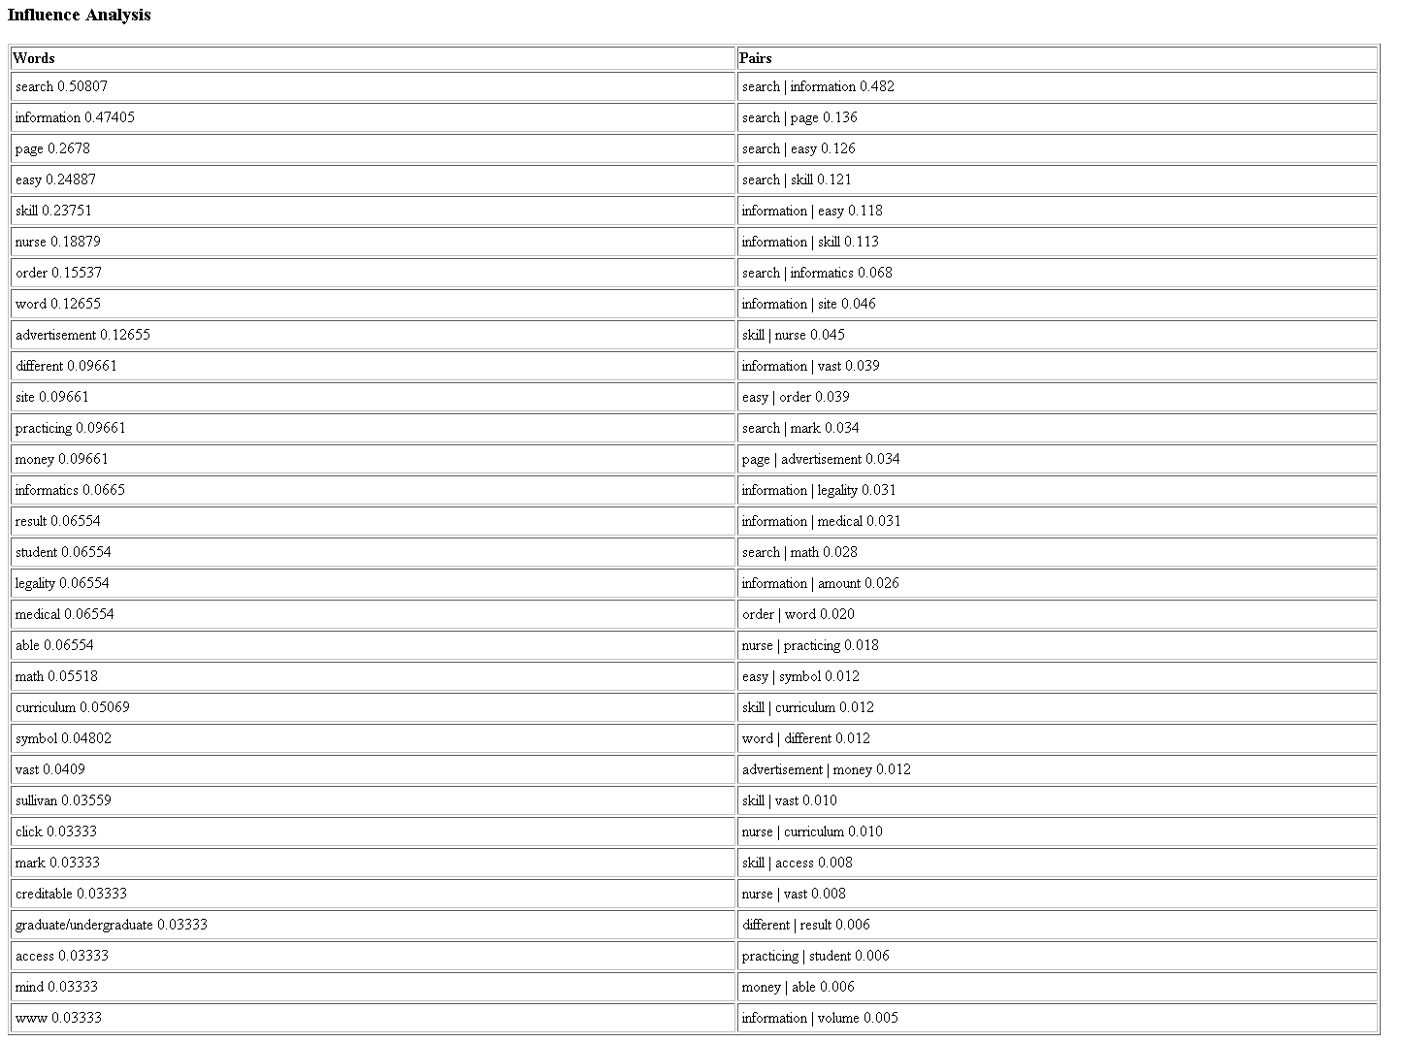
I can choose up to ten of these words or word pairs (as above) and then the software will show the origin of these words in context, as colored background text in the original post:
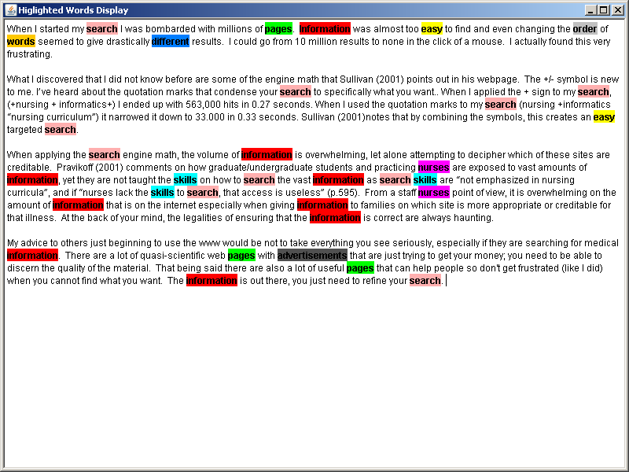

Then I use CmapTools, which is free concept mapping software to generate the concept maps at for each discussion and then link that discussion map to the course concept map, for example:
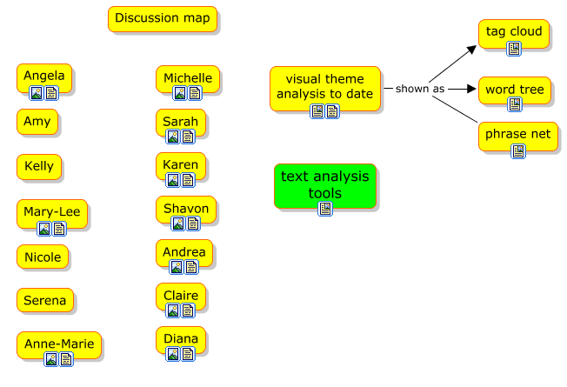

Crawdad Technologies LLC. (2010). Crawdad Desktop 2.0 text analysis software. Retrieved from http://www.crawdadtech.com/html/01_software.html
Institute for Human and Machine Cognition (IHMC). (2010). IHMC CmapTools software. Retrieved from http://cmap.ihmc.us/conceptmap.html

