YELLOWSTONE NATIONAL PARK

Welcome to Yellowstone National Park!
Established in 1872, Yellowstone National Park is America's first national park. Located in Wyoming, Montana and Idaho, it is home to a large variety of wildlife including grizzly bears, wolves, bison, and elk. Preserved within Yellowstone National Park are Old Faithful and a collection of the world's most extraordinary geysers and hot springs, and the Grand Canyon of the Yellowstone.
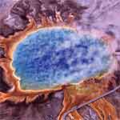 |  | .  Get directions for Yellowstone and learn about the park’s operating hours and seasons, hotel and campground reservations, park fees, and the many natural wonders you can see and activities you can do in Yellowstone.
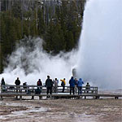 |  | Things to Do  Experience Old Faithful, the most popular geyser in the world, and hundreds of other geysers and hot springs. Look for bears and wolves, elk and buffalo in the Lamar and Hayden Valleys. Hiking, camping, fishing, enjoying exhibits and films, and attending Ranger-led programs are among the many ways to experience Yellowstone.

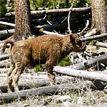 |  | Current Conditions and Updates  Find out what's currently happening in Yellowstone National Park. This page has links to the latest news releases, fire updates, road advisories, and special events.

Climate
Yellowstone's climate is one of cold winters and moderate summers. Most of the park is above 7,500 feet and the weather is unpredictable. Be prepared for changing temperatures, storms and emergencies.

