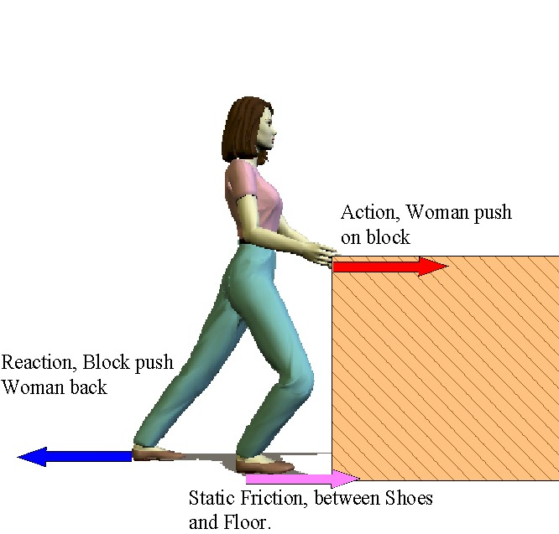

http://www.google.com/imgres?q=friction+force&um=1&hl=en&sa=N&tbm=isch&tbnid=cl9-HUMUd3Y5IM:&imgrefurl=http://dallaswinwin.com/Newtons_Laws/Newton%2520Third%2520Law.htm&docid=kc0TcX_BQtK-rM&w=666&h=637&ei=o5lvTseFFJGltwfcjqlK&zoom=1&iact=hc&vpx=552&vpy=224&dur=313&hovh=220&hovw=230&tx=114&ty=140&page=5&tbnh=135&tbnw=141&start=70&ndsp=18&ved=1t:429,r:14,s:70&biw=1280&bih=603

