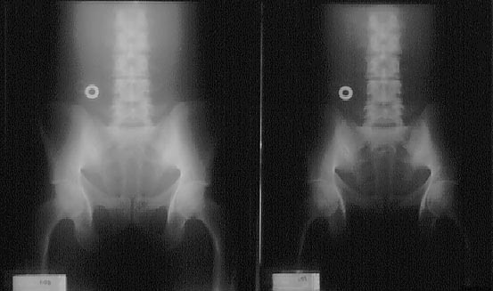

When using AEC for the abdomen, the technologist's choice for detector selection is once again related to the radiologist's preference for darker or lighter radiographs. Although the center, outer two, or all three detectors maybe used for the KUB; selection of the outer two cells is most technically accurate. The KUB radiograph is most commonly ordered to evaluate the soft tissue structures of the abdomen. Selection of the two outer detectors will sample the radiation coming from the soft tissue structures only, resulting in a properly exposed radiograph for the area of interest. Selection of the center cell will result in a slightly darker radiograph because the lumbar spine will attenuate a greater portion of radiation compared to soft tissue, therefore resulting in a darker radiograph. Finally, use of all three detectors will result in a radiograph having density midway between a radiograph taken with the outer detectors and a radiograph taken using only the center detector. This is explained by the fact that the detectors are sampling a portion of the radiation coming from the soft tissue and bony structures. Therefore, an electronic averaging occurs between those structures.
Flat Abdomen
The images below demonstrates the effect of proper cell selection and its affect on density. Radiograph A was taken with the the two outer cells selected, while radiograph B with take with the center cell selected.
https://gvltec.blackboard.com/webapps/portal/frameset.jsp?tab_tab_group_id=_2_1&url=%2Fwebapps%2Fblackboard%2Fexecute%2Flauncher%3Ftype%3DCourse%26id%3D_22147_1%26url%3D

