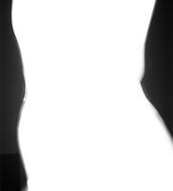
Owing to lack of primary beam collimation on this lateral lumbar spine, the amount of unattenuated radiation striking the imaging plate (IP) (anterior and posterior to the patient) altered the histogram so that it was outside the normal range for that body part selection. Artefact remedy: use the smallest IP practicable and collimate the beam to the body part. This is particularly important on small or slim patients.

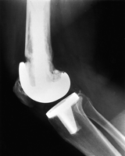
The prosthesis in this knee adds too many extreme pixel values to the image histogram. This results in an image where the difference between prosthesis and glue, or glue and bone is not well demonstrated. Artefact remedy: in computed radiography systems that provide different modes of operation, use of a different image processing mode will alleviate this problem. For example, a semi-automatic or fixed mode will cause the image histogram to be analysed differently from a fully automatic mode and will produce a more acceptable image in cases such as this.

http://bjr.birjournals.org/cgi/content/full/74/878/195#top

