Dryas Julia

[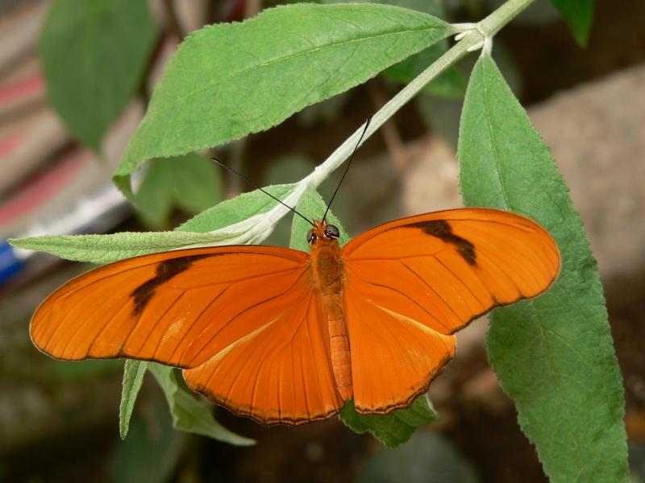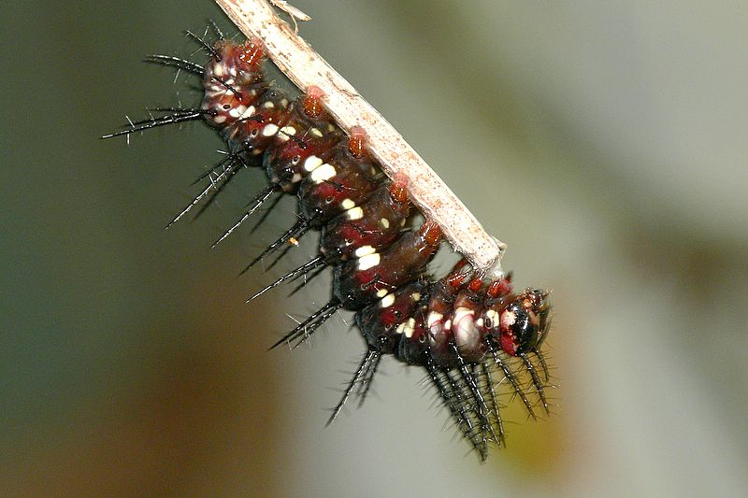](http://www.pbase.com/10kzoomfz/mw_btfy_julia)

[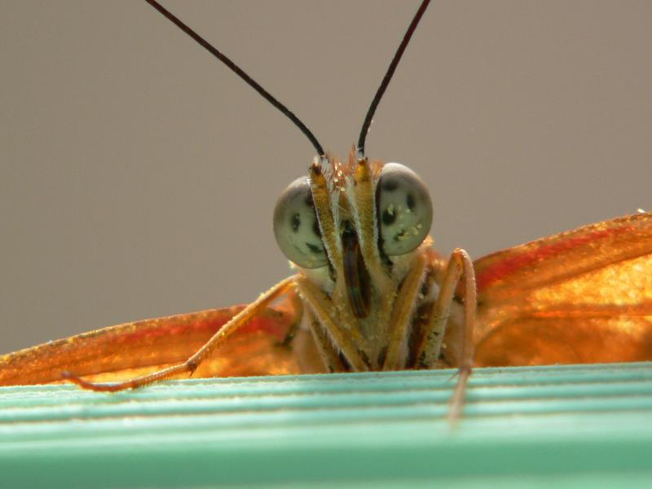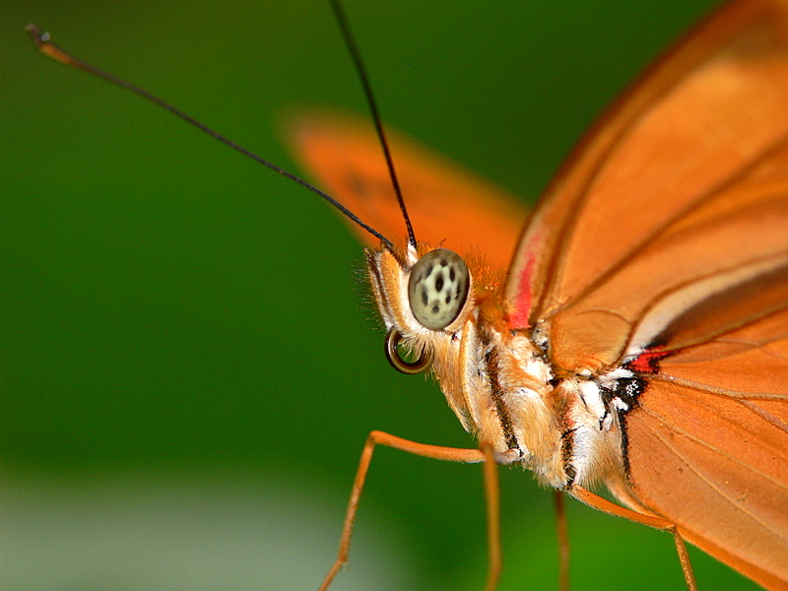](http://www.pbase.com/10kzoomfz/mw_btfy_julia)