Connor Becker
Dr. Tanik
CS360
16 December 2011
SWEBOK KA-3: Software Construction
SWEBOK knowledge area three concerns itself with best practices of actually building software. These practices include “coding, verification, unit testing, integration testing, and debugging.” (SWEBOK Ch. 1) The three subareas of this knowledge area are Fundamentals, Managing Construction, and Practical Considerations.
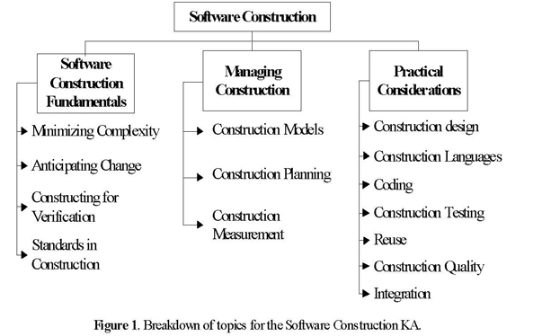
For most computer science students, those of our group included, this is the only knowledge area of SWEBOK applicable they feel is truly applicable. It has taken our group a lot of restraint to not start making prototypes and working models of our project and to instead step back and focus on design. But as with any large project, it is going to be worth the wait; best practices in software construction can only really be effective in a well-thought-out project. So although our group is really not yet close to the construction phase of RUP, it is definitely important to all of us programmers.

