Yeisol Woo

CS460 Senior Capstone Project 1

Homework #3

Review Project Scope Management (PMBOK KA-3)

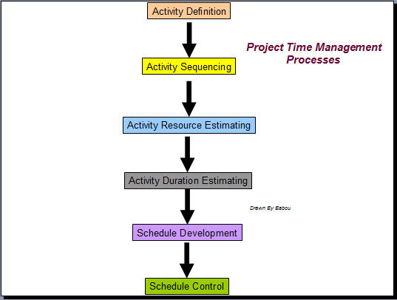

**1. Activity definition**

An activity or task is an element of work normally found on the WBS that has an expected duration, a cost, and resource requirements. Project schedules grow out of the basic documents that initiate a project. The project charter includes start and end dates and budget information. The scope statement and WBS help define what will be done. Activity definition involves developing a more detailed WBS and supporting explanations to understand all the work to be done, so you can develop realistic cost and duration estimates.

An activity list is a tabulation of activities to be included on a project schedule. The list should include: The activity name, an activity identifier or number, and
a brief description of the activity. Activity attributes provide more information about each activity, such as predecessors, successors, logical relationships, leads and lags, resource requirements, constraints, imposed dates, and assumptions related to the activity.

**2. Activity sequencing**

It involves reviewing activities and determining dependencies. A dependency or relationship relates to the sequencing of project activities or tasks. You must determine dependencies in order to use critical path analysis. Three types of dependencies are mandatory dependencies, discretionary dependencies, and external dependencies.

**3. Activity duration estimating**

Activity duration estimating involves assessing the number of work periods likely to be needed to complete each identified activity. The person or group on the project team who is most familiar with the nature of a specific activity make, or at least approve, the estimate.

**4. Schedule development**

Schedule development means determining and finish dates for project activities. If the start and finish dates are not realistic, the project is unlikely to be finished as scheduled. The schedule development process must often be iterated prior to determination of the project schedule.

PERT is a network analysis technique used to estimate project duration when there is a high degree of uncertainty about the individual activity duration estimates. PERT uses probabilistic time estimates: Duration estimates based on using optimistic, most likely, and pessimistic estimates of activity durations, or a three-point estimate.

**5. Schedule control**

Goals are to know the status of the schedule, influence factors that cause schedule changes, determine that the schedule has changed, and manage changes when they occur. Tools and techniques include: Progress reports,
a schedule change control system,
project management software, including schedule comparison charts, such as the tracking Gantt chart.
Variance analysis, such as analyzing floats or slacks. Performance management.