Connor Becker

Dr. Tanik

CS460

1 February 2012

PMBOK KA-2: Project Scope Management

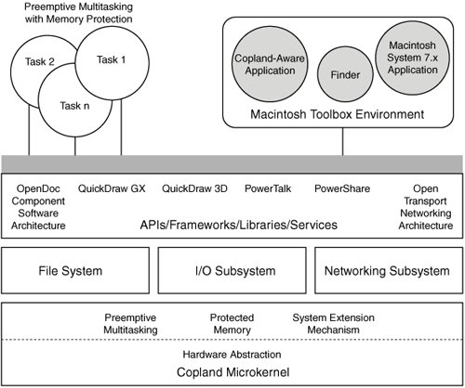 Project scope management is the art of fending off “feature-creep”. The information in this PMBOK Knowledge Area is intended to prepare prospective project managers for the unseen challenge in building a system: designing the system to include only what the client wants, nothing more and nothing less. Engineered projects are bureaucratic in nature, and bureaucracies tend toward expansion and diverging goals. If the project is allowed to add every bell and whistle, or if the project’s workers decide to skip or change the specification, the project is doomed to failure.

Apple’s Copland project aimed to create a new Mac OS. Started in the early 90s, it was finally cancelled in 1996, after nearly bankrupting the company.