Connor Becker

Dr. Tanik

CS460

1 February 2012

PMBOK KA-3: Project Time Management

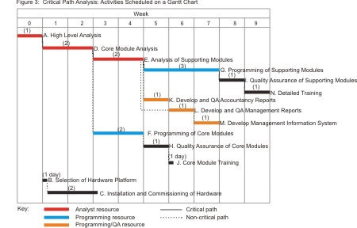 Project time management is the process of scheduling system development and keeping system development on schedule. Most systems are not created from start to finish, but are modular in nature, requiring sometimes that certain portions be completed before others are started. PMBOK Knowledge Area three covers the important points about project component build sequencing and schedule control, and also includes information on how to keep a project on task and forward focused.

A Gantt Chart is one tool that a project manager can use to schedule and keep track of project progress.