Yeisol Woo

CS460 Senior Capstone Project 1

Homework #4

Review Project Human Resource Management (PMBOK KA-6)

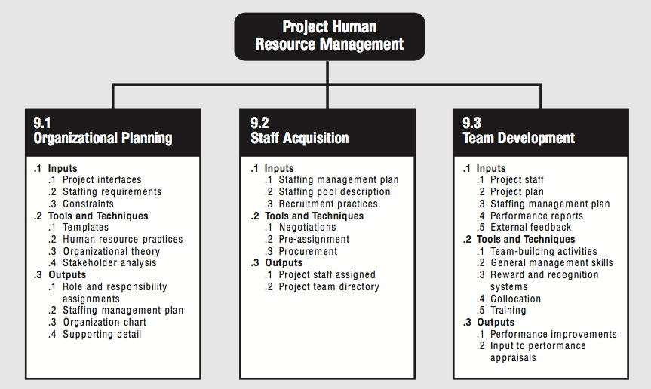

Project Human Resource Management includes the processes required to make the most effective use of the people involved with the project. Figure provides an overview of the following major processes:

9.1 Organizational Planning—identifying, documenting, and assigning project roles, responsibilities, and reporting relationships.

9.2 Staff Acquisition—getting the human resources needs assigned to and working on the project.

9.3 Team Development—developing individual and group skills to enhance project performance.

These processes interact with each other and with the processes in the other knowledge areas as well. Each process may involve effort from one or more individuals or groups of individuals based on the needs of the project.

**9.1 Organizational Planning**

Organizational planning involves identifying, documenting and assigning project roles, responsibilities, and reporting relationships. Roles, responsibilities, and reporting relationships may be assigned to individuals or to groups. The individuals and groups may be part of the organization performing the project or they may be external to it. Internal groups are often associated with a specific functional department such as engineering, marketing, or accounting.

On most projects, the majority of organizational planning is done as part of the earliest project phases. However, the results of this process should be reviewed regularly throughout the project to ensure continued applicability. If the initial organization is no longer effective, it should be revised promptly. Also, Organizational planning is often tightly linked with communications planning since the project’s organizational structure will have a major effect on the project’s communications requirements.

Tools and Techniques for Organizational Planning: Templates, Human resource practices, organizational theory, and stakeholder analysis.

**9.2 Staff Acquisition**

Staff acquisition involves getting the human resources needed (individuals or groups) assigned to and working on the project. In most environments, the “best” resources may not be available, and the project management team must take care to ensure that the resources which are available will meet project requirements.

Tools and Techniques for Staff Acquisition: Negotiation, Pre-assignment, and Procurement.

**9.3 Team Development**

Team development includes both enhancing the ability of stakeholders to contribute as individuals as well as enhancing the ability of the team to function as a team. Individual development (managerial and technical) is the foundation necessary to develop the team. Development as a team is critical to the project’s ability to meet its objectives.

Team development on a project is often complicated when individual team members are accountable to both a functional manager and to the project manager. Effective management of this dual reporting relationship is often a critical success factor for the project and is generally the responsibility of the project manager. Team development occurs throughout the project.

Tools and Techniques for Team Development: Team-building activities, General management skills, Reward and recognition system, Collocation, and Training