Yeisol Woo
CS460 Senior Capstone Project 1
Homework #1

Review Software Requirements (SWEBOK KA-1)

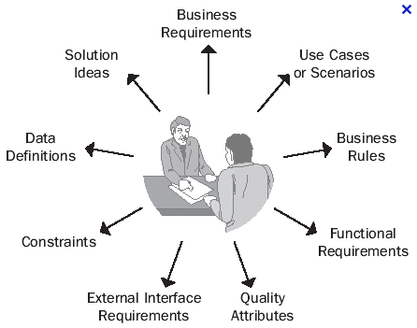

The software requirements knowledge area of SWEBOK deals with the elicitation, analysis, and validation of software requirements. A software requirement is a property that must be exhibited in order to solve some real-world problem. The knowledge area is further broken down into the following sub-topics: software requirements fundamentals, requirements process, requirements elicitation, requirements analysis, requirements specification, requirements validation, and practical considerations.
Since software requirements help to dictate what needs to be completed for a software engineering project to be considered a success, we dealt with this knowledge area a lot with our project. First, we had to solicit our clients for a set of features that they needed in the final product. This gave us a rough set of functional requirements. From there, we had to analyze each of the requirements to discover any possible resulting requirements. For example, the client requested that the system be able to process X number of queries per minute. As a result, the system gained the functional requirements of having to be deployable to a server that could handle those queries at that rate. Furthermore, the system had to be able to communicate to the different parts quickly enough to transfer the necessary information in an efficient manner. Once we had a more formal set of requirements, we had to verify that the requirements were accurate in relation to the original set of requested features from the client. To do this, we analyzed each requirement, along with any of its sub-requirements, to see if it met the corresponding client requested feature. We then made adjustments and additions to the set of requirements as needed to ensure that all of the feature requests were met. Finally, we met with our client to share our findings. After receiving positive feedback from the client that our findings met their requests, we were able to start the project design process.

