Yeisol Woo
CS460 Senior Capstone Project 1
Homework #10

Review Software Quality (SWEBOK KA-10)

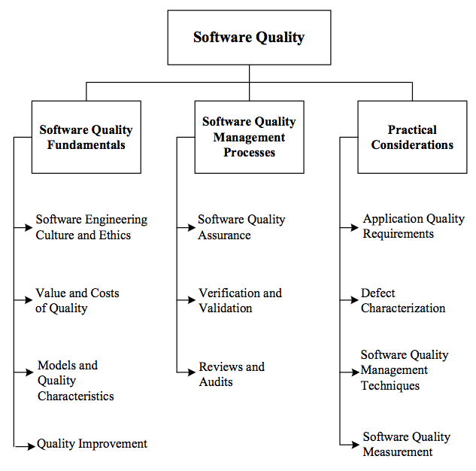

The software quality knowledge area of SWEBOK deals with software quality consideration, which transcends the software life cycle processes, that includes areas such as software quality fundamentals, software quality management, and practical considerations. More specifically, quality is “the degree to which a set of inherit characteristics fulfills requirements.” The knowledge area is further broken down into the following sub-topics: software quality fundamentals, software quality management processes, and practical considerations.
As with any other software system project, quality is one of our project’s major concerns. Our biggest measure of software quality is how well the behavior of our software system matches the expected behavior. This expected behavior comes from the set of software requirements specified during the earlier life cycles. Another measure of quality for our project was the amount of bugs in the system. To minimize the number of bugs, we ran our system, its modules, and even its sub-modules through a rigorous set of testing. These tests, whether they be unit test or manual tests, were designed to ensure that all data is stored, retrieved, and displayed accurately. Furthermore, the manual tests’ results were used to compare the behavior of the system in comparison to the client’s expected behavior. For instance, if a particular screen was supposed to display a set of information in a certain way, then we analyzed the presentation of the data and compared that to how the data was supposed to be presented.

