Yeisol Woo

CS460 Senior Capstone Project 1

Homework #3

Review Software Construction (SWEBOK KA-3)

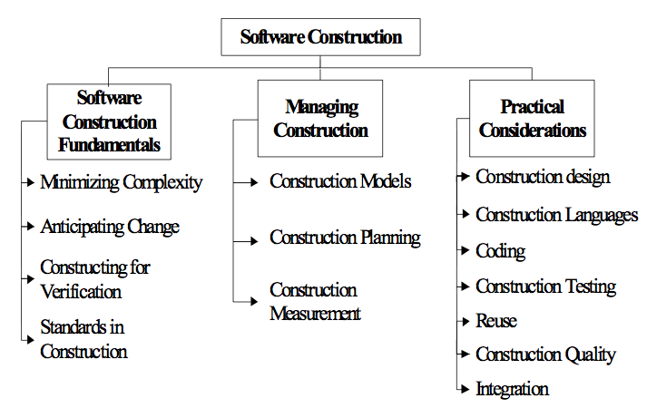

The software construction knowledge area deals with the translating the software design into the software system. More precisely, construction is the creation of a working software system through a combination of programming, verification, testing, and debugging. The knowledge area is further broken down into the following sub-topics: software construction fundamentals, managing construction, and practical considerations.

Just as with software requirements and software design, this phase of the project took a great deal of time as it encompassed several different phases including coding, testing, and debugging. To begin, we analyzed the software design we came up with in during the design phase of the project. We took a look at both the textual and graphical representations of the design to make sure that we fully understood the layout of the software system as a whole. From there, we began coding the actual modules for the system. Since we were following a pseudo rapid application development process in our development, we tested each of the modules after every major build. For instance, after finishing each major portion of the database / persistence layer, we ran unit tests on data inserts, deletes, updates, etc. We then analyzed the results in tandem with working on the other modules. Once the results were analyzed, we revisited any problem areas to apply fixes. Once that set of fixes was complete, we retested the affected modules. We continued to follow this cycle of code-build-test-fix until each module was complete. We also ran other tests on the sub-systems of the project as each one became complete. For instance, once we had the backend system complete, we ran a series of unit tests as well as manual tests on the system to ensure that all data transactions met the ACID requirements as well as data was transferred accurately. Once these tests were complete, we analyze the results and applied fixes as needed. We then re-ran these tests to see if the fixes were successful as well as to test if any new problems arose. This same cycle was applied to the system as a whole once all major modules were in place.