Yeisol Woo
CS460 Senior Capstone Project 1
Homework #11

Review Related Disciplines of Software Engineering
(SWEBOK KA-11)

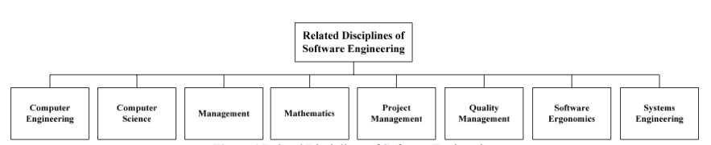
The 11th knowledge area of SWEBOK is the related disciplines of software engineering. It is comprised of fields that, while not specifically part of software engineering, have a strong tie to software engineering. Some of the related disciplines include: computer engineering, computer science, management, mathematics, project management, quality management, software ergonomics, and systems engineering. Each of these disciplines is then further broken down into a set of sub-topics related to each major field.
For our project, we mostly focused on the following disciplines: computer science, project management, quality management, software ergonomics, and systems engineering. For the computer science discipline, we used what we had learned in our standard computer science courses to help design and implement the system. We used standard design principles to model our project after and we used standard algorithms and programming practices to implement the actual system. For the project management discipline, we used various project management techniques to help organize and guide our development process. Some of the techniques included time management, task delegation, etc. For the quality management discipline, we tested our system using a combination of unit and manual tests to ensure that the behavior of the system matched the expected behavior and that as many bugs were worked our of the system as possible. For the software ergonomics discipline, we worked on designing an interface that was both logical and easy to learn and use. Since a major portion of the user interface was to be used in a police cruiser, it had to have special considerations taken into account. Data had to be presented in a quick and easy to process manner and controls had to be optimized for a touch screen interface. Finally, for the systems engineering discipline, we designed a software-hardware hybrid system that allowed the data to be stored in a separate back end and viewed and altered in a separate front end. The communications between the different ends were then designed and optimized to fit the needs of the different client computers (i.e. minimized round trips between the cruiser client and the back end due to high response times).

