Yeisol Woo
CS460 Senior Capstone Project 1
Homework #9

Review Engineering Tools and Methods (SWEBOK KA-9)

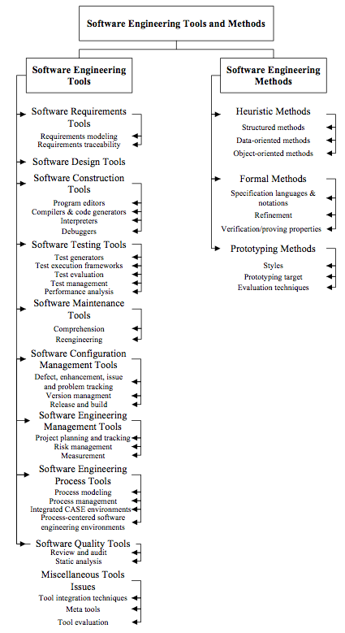
The software engineering tools and methods knowledge area of SWEBOK deals with the different tools and methods available to assist in the software engineering process. More specifically, the engineering tools KA covers both software engineering tools and software engineering methods. Engineering tools are tools that aid in the engineering process in ways such as making collaboration easier, helping manage quality checks, etc. Software engineering methods include areas such as heuristic methods dealing with informal approaches, formal methods dealing with mathematically based approaches, and prototyping methods dealing with software development approaches based on various forms of prototyping. The knowledge area is further broken down into the following sub-topics: software engineering tools, and software engineering methods.
In order to meet our project deadline, we used a number of different tools and methods to assist in our software engineering efforts. As far as tools go, we used a number of organizational tools such as Acclaro DFSS. This tool allowed us to gather, organize, and analyze our functional requirements. We also used a tool call SVN, or subversion, to help manage our version control system. This tool allowed us to ‘check out’ copies of the project code, make the necessary changes, and then upload said changes to a new revision of the tree. Not only did this allow us to work simultaneously on different portions of the project, but also it also allowed us to manage changes made to the project and backtrack when needed. To assist in the actual coding of the project, we used an integrated development environment called Netbeans, along with a number of plugins such as Java development, Java EE development, JavaScript development, database development, etc. to help us code the system quicker. The assistance from this tool and its plugins came in the form of debugging, code completion, and to some degree, code generation. We also used a tool called BOUML to create and manage our different UML diagrams that described the design of the system. BOUML also has a number of useful features such as exporting to HTML for documentation purposes as well as code generation from UML class diagrams. We also employed a number of different software engineering methods such as the RAD process to help guide our development process.

