Yeisol Woo
CS460 Senior Capstone Project 1
Homework #8

Review Software Engineering Process (SWEBOK KA-8)

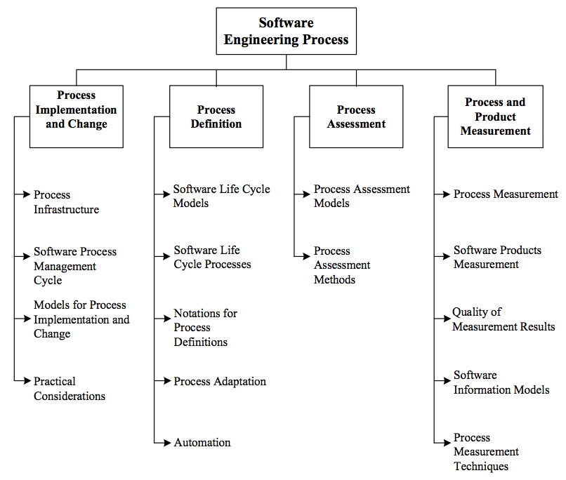
The software engineering process knowledge area of SWEBOK deals with the software life cycle processes. More specifically, the software engineering process deals with the definition, implementation, assessment, measurement, management, change, and improvement of the software life cycle processes. The knowledge area is further broken down into the following sub-topics: process implementation and change, process definition, process assessment, and process and product measurements.
The ties between this knowledge area and our project are rather loose at best. The relation can be found in our definition and implementation of the software life cycle processes. For example, we went through and decided what work needed to be done in each of the different cycles. Most of our team had never implemented a large-scale software system before, so the idea of segregating the project into specific parts was a difficult task. We had to segregate the processes of requirements analysis, design, implementation, and testing into different sections. We then implemented the plan for each life cycle phase as needed. For the most part, however, our project never dealt with the other parts of this knowledge area. For example, we never really assessed or measured the effectiveness of our life cycles. Furthermore, we did not have to make or management many changes to our life cycles. Some changes, however, were necessary, as we had to reassign certain tasks to other life cycles to better suit our development. While some tasks were reassigned due to changing group dynamics, other changes were made in order to ensure that relevant work was being completed during each of the different life cycle phases.

