Yeisol Woo

CS460 Senior Capstone Project 1

Homework #7

Review Software Engineering Management (SWEBOK KA-7)

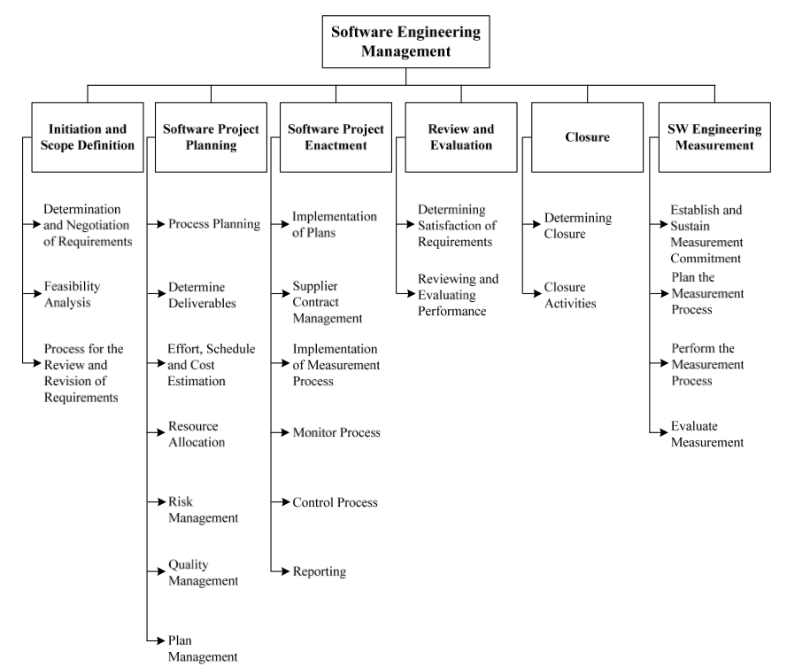

The software engineering management knowledge area of SWEBOK deals with, as the name implies, management as well as measurement of software engineering. The knowledge area is further broken down into the following sub-topics: initiation and scope definition, software project planning, software project enactment, review and evaluation, closure, and software engineering measurement.

Our project dealt with some of the different sub-topics in this knowledge area. For example, the project team had to initiate the project by soliciting project ideas from the client as well as other interested parties. These ideas were paramount in the formation of the project requirements and design. We also had to define our project scope before analyzing software requirements. As development continued and our project evolved, so did this project scope. As more and more features were requested either by the client or by our own team members, we had to combat scope creep to ensure that the project did not get out of hand. Since we had only a single semester to complete the project, we did not have the luxury to allow the scope of the project to expand very far. Also, since we had such a tight schedule to meet, we had to plan our time wisely in order to ensure all portions of the project were completed on time, especially if other modules depended on that portion of the project. We did not, however, have time to review or evaluate much of our software engineering management. We also did not have adequate time to perform measurements upon our software engineering management. These tasks will surely take place during our project debriefing following completion of the project.