Connor Becker
Dr. Tanik
CS360
16 December 2011
SWEBOK KA-8: Software Engineering Process
This SWEBOK KA is concerned not with the process of engineering software itself, but the definition of what that process will entail. The SWEBOK document calls this a “meta definition” of process and this is stressed above the actual lifecycle of the project. KA-8 includes the subareas “Process Implementation and Change”, “Process Definition”, “Process Assessment”, and “Process and Product Management”.
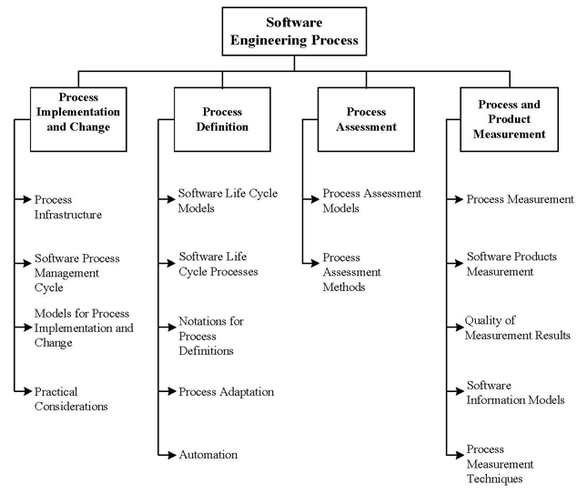
My group has been very concerned with the meta task of figuring out the process that our project will undertake. RUP has been a big help and guiding star for our group. But there have been hurdles along the way, having to go back because of the application architecture being out of sync with our axiomatic design process. But we've managed.

