Connor Becker
Dr. Tanik
CS360
16 December 2011
SWEBOK KA-7: Software Engineering Management
SWEBOK KA-7 concerns the use of management techniques to oversee and organize software engineering activities. Consistent with SWEBOK's primary assumption, that the development of software is best undertaken as an engineering discipline, KA-7 seeks to explain how to “manage software engineering in the same way as any other (complex) process”. While it does acknowledge that there are some caveats that come about through the nature of the developer customer relationship and the usually iterative process of software development, KA-7 epitomizes the SWEBOK mindset of process and workflow control.
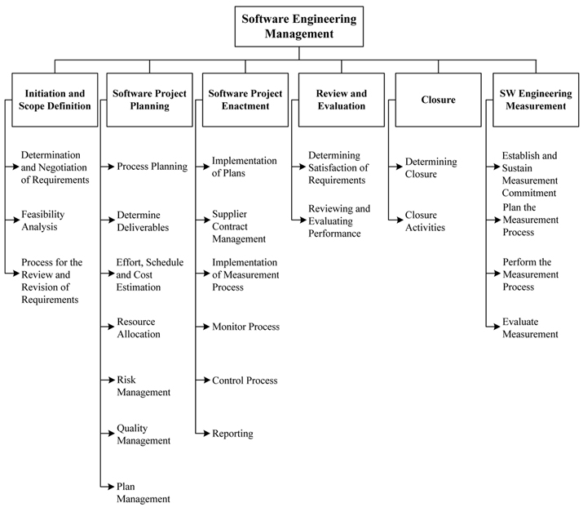
Software engineering management became very important to my group early on in the semester. Our group leader's management style wasn't working out—he was taking a hands off, laissez faire approach leaving the group wondering what was going on. We came to terms with it and started moving toward a more delegated task-assignment style which worked much better for us.

