Connor Becker
Dr. Tanik
CS360
16 December 2011
SWEBOK KA-5: Software Maintenance
Although a group of engineers delivers a product that meets its specifications and testing requirements and importantly, its deadline, that may not be the end of the story. An organization that orders a product built has a set of needs that need met today but those needs may change in the future. Thus, software maintenance. The SWEBOK guide talks about the subareas of fundamentals, key issues, process, and techniques.
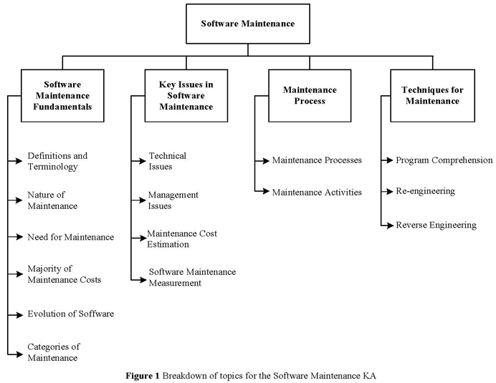
The MyIPFWAdvisor project is one that will require ongoing maintenance throughout its life span (can't say cycle, since maintenance is part of the cycle). Although when complete it will contain tools to facilitate the updating of the system's content, delivery and database interaction mechanisms will have to change along with the school's other systems in order to remain relevant.

