Connor Becker
Dr. Tanik
CS360
16 December 2011
SWEBOK KA-4: Software Testing
Testing is the art of making as perfectly sure as possible that the software product not only meets specifications but also performs its task without errors. This involves searching for programming errors, verifying correct behavior, and running predefined test cases against the program. The SWEBOK guide states that software testing is not just an activity that goes on after coding but should be an activity that is taken part in throughout the process of building the software.
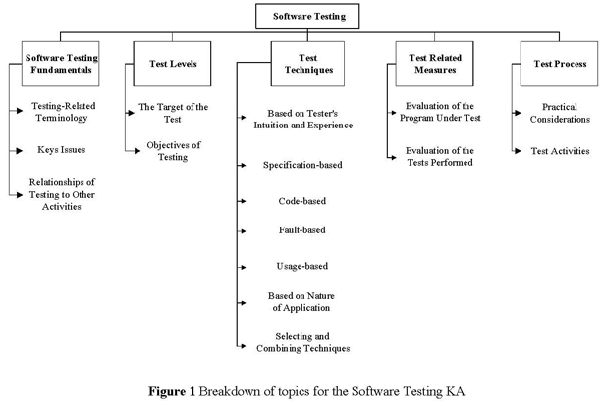
Although my group hasn't actually done more than token construction on its project, testing will play a major part in our work. Our project is designed to be rolled out to live servers in the future hosting critical data and manipulation operations—errors during its public running will be this side of unacceptable.

