Connor Becker

Dr. Tanik

CS460

12 April 2012

PMBOK KA-4: Project Cost Management

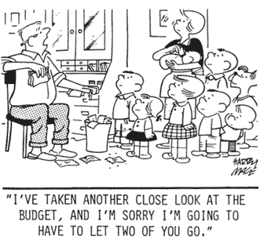 Tying in with knowledge area 3, PMBOK KA-4, Project Cost Management deals with bringing a project in within the predetermined budget. This area includes the subareas Resource Planning (deciding when, where, or whether resources will be used and for what tasks), Cost Estimating (making informed predictions as to what the project will cost), Cost Budgeting (deciding which tasks get what funds), and Cost Control (regulating changes to the project due to changes in the budget). These subareas are sometimes seen as a single entity, but as projects become large, the delineations become more apparent and “interfaces” between the subareas can be seen.

Sometimes budgets involve hard choices.

<http://www.airpurifiers.com/tips.htm>