Connor Becker

Dr. Tanik

CS460

12 April 2012

PMBOK KA-5: Project Quality Management

Project Quality Management is the process of making sure the engineered software fulfills the project’s specification. This is the “quality control” of the software engineering assembly line, but is also the process of planning how the finished product will be tested for specification compliance and if applicable what standards will be used for that testing. The subareas of Project Quality Management are Quality Planning, Perform Quality Assurance, and Perform Quality Control.

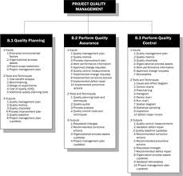 While all projects require application specific tests to be developed, The PMBOK Guide makes clear that all projects regardless of subject matter will engage in some sort of Project Quality Management.