Connor Becker

Dr. Tanik

CS460

19 April 2012

PMBOK KA-8: Project Risk Management

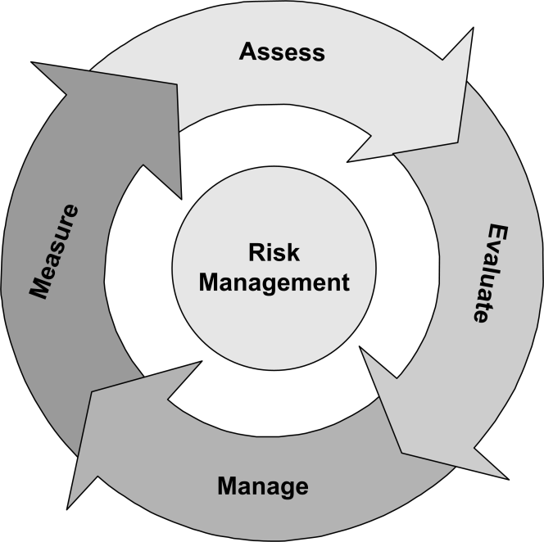 Project Risk Management is the knowledge area that concerns itself with “The objectives of Project Risk Management are to increase the probability and impact of positive events, and decrease the probability and impact of events adverse to the project.” It’s sub areas are: (1) Risk Management Planning, the decisions made on how to create and apply risk management plans to the project; (2) Risk Identification, the process of identifying what risks the project is subject to; (3) Qualitative Risk Analysis, the prioritization of risks; (4) Quantitative Risk Analysis, quantifying the impact of risks on the project; (5) Risk Response Planning, mapping out actions to be taken to reduce risk occurrence, and (6) Risk Monitoring and Control, keeping track of risks and putting them down while identifying new risks and assessing the effectiveness of the response plans.