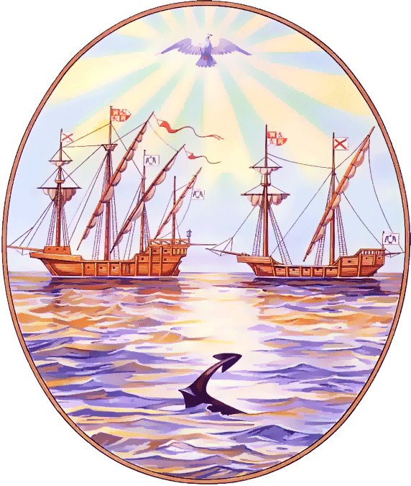

G O B I E R N O DE LA C I U D A D DE B U E N O S A I R E S
“2012. Año del Bicentenario de la Creación de la Bandera Argentina”
Centro Educativo de Nivel Secundario Nº 35
Año: 2012

Asignatura: INGLES

Profesor/a: Eliana Coda Bertetto Curso: 3° año “C”

PROGRAM

Revision and use of grammar and vocabulary introduced in the previous course.

Vocabulary and Topics | Grammar
Years  Biographies  Past Time Expressions | Simple Past Tense  Verb To Be  Affirmative - Negative - Interrogative: Yes/No-Questions and Wh-Question
Past Events  Past Time Expressions  Travel  Life Changes | Simple Past Tense  Regular and irregular Verbs  Affirmative - Negative - Interrogative: Yes/No-Questions and Wh-Question
Future Events  Future Time Expressions  Plans  Decisions  Predictions  Life Changes | Simple Future Tense  Will - Shall  Affirmative - Negative - Interrogative: Yes/No-Questions and Wh-Question

Bibliography Soars, Liz and John, New Headway Beginner, Oxford University Press, 2009

