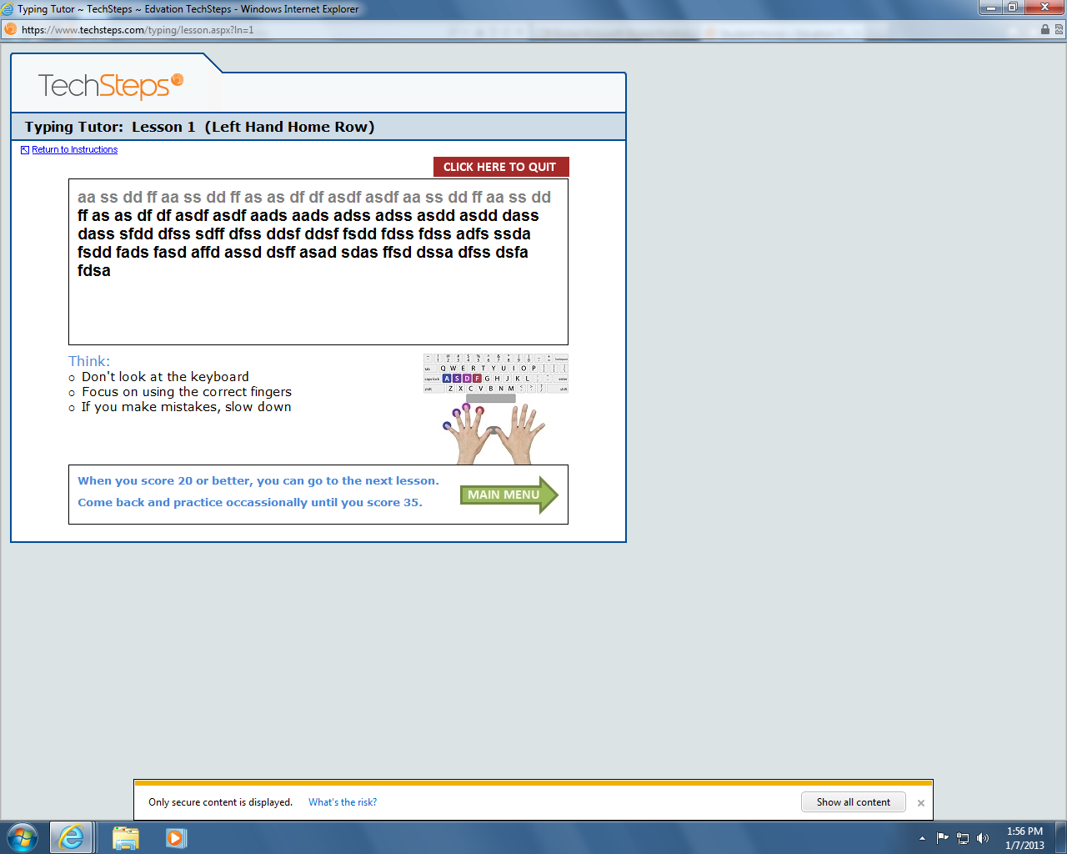1713-Christina Medeiros-L1-77635

