[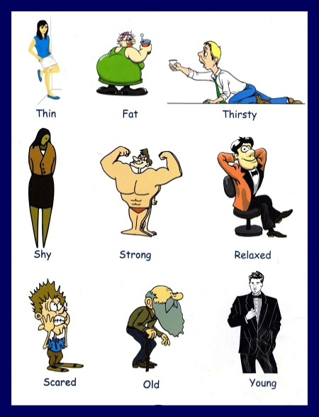](http://www.google.com.pa/url?sa=i&rct=j&q=&esrc=s&frm=1&source=images&cd=&cad=rja&docid=LnvV1LDfc9A5oM&tbnid=iG-dBYcd1ZRG4M:&ved=0CAUQjRw&url=http://www.grammarbank.com/adjectives-pictures.html&ei=1iGLUaryA4G48wSp0IC4Bw&bvm=bv.46226182,d.eWU&psig=AFQjCNGtNH6py_nilJvFMyePN7Lpp2vYAg&ust=1368159053787615)