Sample Investigation Plan: Scientific Inquiry

Who Goes There?

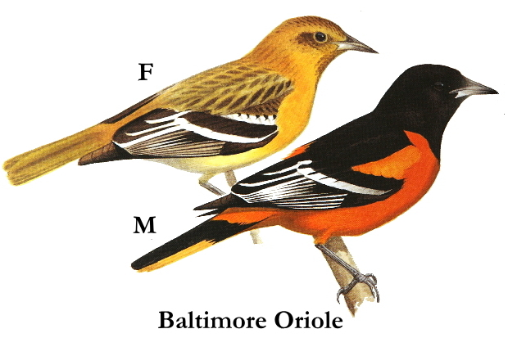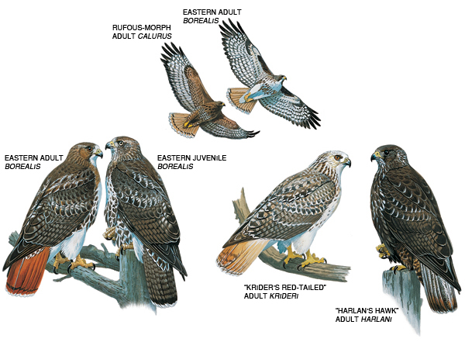

Investigation Designer: Carol Baird Molander

Grade level: 7 Subject: Life Science

Inquiry Scale: Structured

Time Required:
Ongoing throughout the school year, one class per month, 75 minutes per class
Note: My four classes will be participating in the activity. Each class will collect data once per month for approximately 20 minutes in an outdoor location. Each class will collect data on alternate weeks. This will allow for continuous data collection for the ten months of the school year. Thus, a wealth of data to be could be analyzed at the end of the school year. Obviously, there are several vacation weeks during the year. Data will not be collected during these weeks.

Investigation Focus:
Opening in August 2013, our new grades 7-12 school building, and area surrounding it, has created a different habitat from the existing one. For example, parking lots with newly planted trees and bushes replace a once open field. Given this change, I thought my students would wonder about what living things might be observed in the area. Since birds could be observed in the vegetation, on the ground, around a nearby stream, or overhead, I predict that they would be an animal with which we could easily collect data throughout the school year.

State Learning Standards:
Inquiry Grades 6-8
• Present and explain data and findings using multiple representations, including
tables, graphs, mathematical and physical models, and demonstrations.
• Draw conclusions based on data or evidence presented in tables or graphs, and make inferences based on patterns or trends in the data.
Grades 6 – 8
10. Genetic variation and environmental factors are causes of evolution and the diversity of organisms.
Grades 6– 8
13. Organisms interact and have different functions within an ecosystem that enable the ecosystem to survive.

Learning Outcomes:
Use skills of observation, using all possible senses
Understand there are a variety of birds in the area, describe their characteristics
Select and Identify birds using field guides and other sources
Collect and record accurate data
Analyze data and formulate conclusions about the birds in on the school’s property
Create a method to represent group data and findings
Create a method to share class findings with others

Materials list:
Paper, pencil, data sheet, clipboard or notebook, bird field guides, Audubon Bird or similar electronic application to identify birds, electronic device (smart phone, iPad or computer with internet access), digital reader (to project book pages for identification) and Smart Board (to project information for the class to observe)
Optional: binoculars, camera
Other materials available to represent data and share findings: colored pencils, markers, graph paper, ruler, glue stick, scissors, construction paper, drawing paper, computer and printer
Data sheet: See example on document Data Sheet ebhs
Maps of school grounds
Rubric

Engaging Experience:
During the first week of school, students will be given a tour of the new building and the school’s grounds. This will help to orientate them to their new school. In science class, they will do a mapping activity of the school’s property from observing the property, using photos and blueprints from the high school building committee web site http://www.newebschool.org/documents/EBHS_SiteLandscapePlan.pdf and Google Earth map of the the school at 11 Plymouth Street East Bridgewater, MA.
(See attached map or document entitled ebhs map.)The students will be asked to brainstorm the differences of living things between the old and new properties. Some may come to the conclusion that the animals’ habitats have changed . The teacher can then ask, which animals? Birds? Did we see any birds on during our orientation walk? Where did you see them?

Guiding Question(s):
Which types birds are seen on the grounds of our new school?
Can you identify the types and numbers of birds on the school grounds?
Why are the birds living around our school?

Investigations:
To explore the questions, students will collect data using a data sheet (see sample). For about 20 minutes, they will work in groups of four or five to count birds within an outdoor assigned location over the course of the school year, September through June. They will record the date, types and numbers of birds they observe on the data table for further study. Students will also describe any observed behaviors.
ors. They may take photographs or sketch the birds they see. Once inside the classroom, they will use electronic bird identifying applications, bird field guides and adults as resources to identify the birds they observed. They will do this once per month for a class period. They will keep their data tables in a section of their science binder. Vocabulary could be placed on an informational board in the classroom with photographs of common birds to the area. This may help with identification and keying interest in the ongoing project.

Present Findings and Draw Conclusions:
In early June, a class discussion may be held to analyse the findings. Working in their groups, students will design and create a way to represent the evidence of their findings. The representations could be displayed or explained by students for sharing findings with others. For example, they might design a EBHS Bird Field Guide including the species they observed and other facts.
For students having difficulty, suggestions or samples may be displayed for inspiration.
The data from all four of the class’ groups will be represented in a created form. For example, the students might think of using a graph.

Vocabulary:
1. Common name‐ a bird’s non‐scientific name
2 Field guide‐ a book with illustrations and descriptions of various bird species
3. Migrate‐ moving from one part of the world to another, usually in spring or fall
4. Scientific name‐ internationally standardized genus and species names written in Latin or Greek
5. Habitat‐ the area a bird lives in; can be described by food, water, shelter, and space availability

Assessment:
Observation of students’ participation during their data collection in the field
Participation in discussion of findings
Rubric for the representation of findings including dates, number and types of birds found throughout the year.

Resources:
Audubon Bird (or similar applications for electronic devices)
BirdSleuth: Investigating Evidence Resource Materials, Cornell Lab of Ornithology, http://www.allaboutbirds.org/Page.aspx?pid=1189#.UfCMvo2sg1g
East Bridgewater Schools web site: ebps.net
Google Earth

Wrap Up:
Follow up questions from the students may be answered by other students. Information will be compared and contrasted with future data for years to come.
Adaptation to Different Inquiry Levels -guided to open inquiry:
• What are the behaviors of birds found in our areas?
Create a way to encourage birds to enter our school grounds.
Students may use their findings to research ways of encouraging more birds or different types of birds to the school grounds. Example: planting flowering trees known to attract cedar waxwings or other fruit eating birds
• What do birds need to survive?
They might design a “best habitat” for birds
• Why do we see different birds at different times of the year?
They may ask other questions about different species seen at different times of the year which could lead to an investigation on migration.

