UPS 2 SESSION 2013/2014 (QUESTION)
Bil. | Question | Elaboration
1 (a) | FIGURE 1 shows the diversity of bacteria based on their shape  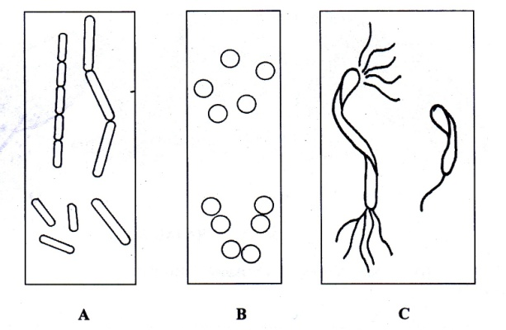  FIGURE 1
State the shape of bacteria A and C.
[2 marks]
Give ONE example of bacteria B.
[1 marks]
State another TWO ways of bacterial classification.
[2 marks]
- (b) | FIGURE 2 shows TWO types of organisms in different kingdom.  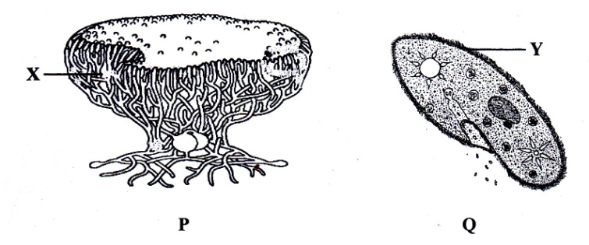  FIGURE 2
Name the structure labelled X and Y.
[2 marks]
What is the feeding mode of species P and Q.
[2 marks]
How fungi help in production of ‘tempe’ and ‘tapai’?
[1 mark]
Bil. | Question | Elaboration
2. | FIGURE 3 shows three types of worms.  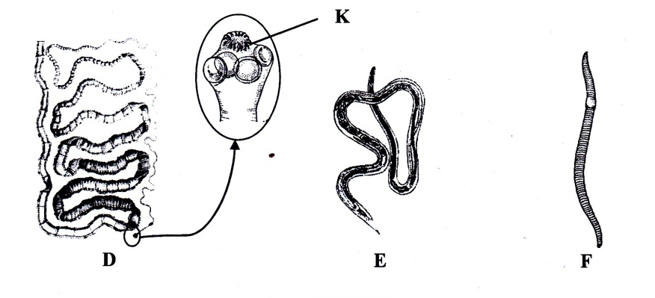  FIGURE 3
(a) | Name structure K and give its function.  [2 marks]
(b) | Identify phyla D and E  [2 marks]
(c) | Give TWO similarities between worm D and E  [2 marks]
(d) | State the body cavity possessed by D and F.  [2 marks]
(e) | Elephantiasis is caused by a specific type of worm. Name the worm.  [1 mark]
(f) | Why Hirudo sp. is used in cupping treatment?  [1 mark]
Bil. | Question | Elaboration
3 (a) | FIGURE 4 shows tropical rain forest stratification.  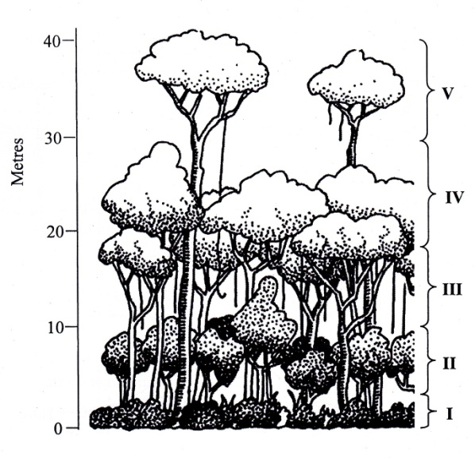  FIGURE 4
i. | Name layers II and IV.  [2 marks]
ii. | Give ONE example of dominant plant and animal at layer V.  [2 marks]
iii. | Why this forest is called as tropical rainforest?  [1 mark]
3 (b) | FIGURE 5 shows population growth of two species of Paramecium.  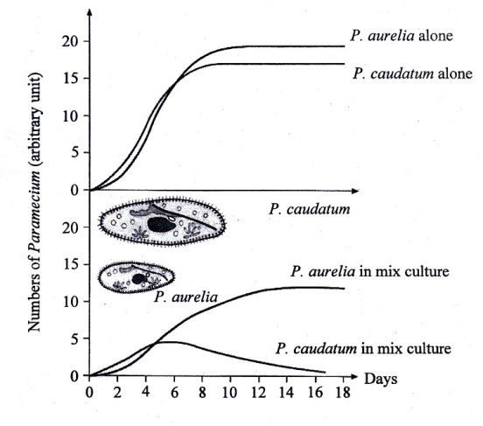  FIGURE 5
i. | Name the population growth curve shown by Paramecium.  [1 mark]
ii. | State TWO density dependent factors in the mixed cultured.  [2 marks]
iii. | Give TWO reasons why P.aurelia has advantage over P. caudatum.  [2 marks]
Bil. | Question | Elaboration
4. | FIGURE 6 shows a type of speciation within a beetle population over hundreds years.  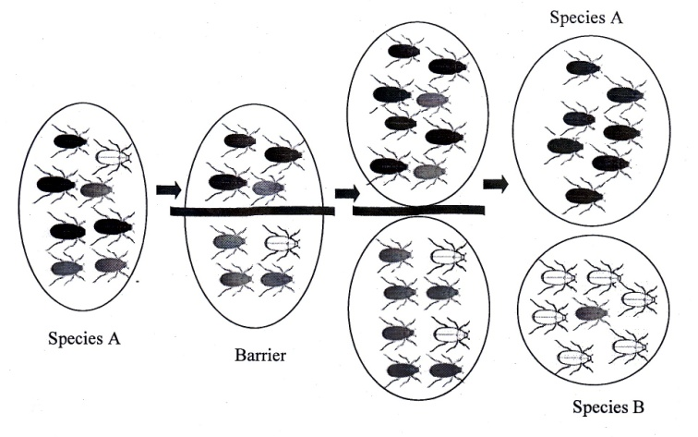  FIGURE 6
(a) | Define speciation.  [1 mark]
(b)i. | Identify the mode of speciation in FIGURE 6.  [1 mark]
(b)ii. | Explain your answer in 4(b)(i).  [2 marks]
(c) | List TWO factors involve in the formation of new species.  [2 marks]
(d) | Briefly describe the bottleneck effect.  [2 marks]
(e) | How founder effect can lead to the formation of new species?  [2 marks]

UPS 2 SESSION 2013/2014 (ANSWER SCHEME)
Bil. | Question | Elaboration
1 (a) | FIGURE 1 shows the diversity of bacteria based on their shape  FIGURE 1
State the shape of bacteria A and C.
[2 marks]
A : Rod/ bacillus/ streptobacillus
C : Spiral/ spirillum/ spirillium
Give ONE example of bacteria B.
[1 marks]
Staphylococcus sp. / Streptococcus sp./ Nostoc sp./ Sulfolobus sp.

State another TWO ways of bacterial classification.
[2 marks]
- Gram Stain
- Position of flagella

- (b) | FIGURE 2 shows TWO types of organisms in different kingdom.  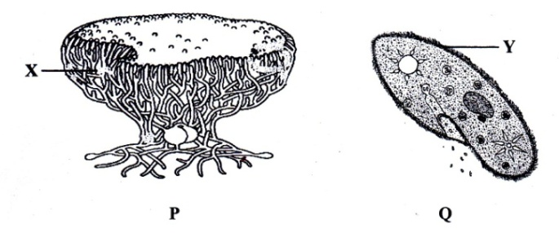  FIGURE 2
Name the structure labelled X and Y.
[2 marks]
X : Mycelium
Y : Cilia/ cillium

What is the feeding mode of species P and Q.
[2 marks]
P : Saprophytic
Q : Heterotroph

How fungi help in production of ‘tempe’ and ‘tapai’?
[1 mark]
Undergo alcohol fermentation/ anaerobic respiration
Bil. | Question | Elaboration
2. | FIGURE 3 shows three types of worms.  FIGURE 3
(a) | Name structure K and give its function.  [2 marks]  K : Hook  Function : Enables the parasite to attach to the
(b) | Identify phyla D and E  [2 marks]  D : Platyhelminthes  E : Nematoda
(c) | Give TWO similarities between worm D and E  [2 marks]  - Both have unsegmented body  - Both are parasite  - Both are triploblastic  - Bilateral symmetry  - Have cephalisation  - Have true tissue/ eumetazoa.
(d) | State the body cavity possessed by D and F.  [2 marks]  D : Acoelomate/ acoelom  F : Coelomate/ coelom
(e) | Elephantiasis is caused by a specific type of worm. Name the worm.  [1 mark]  Brugia malayi/ Nematia sp./ Wuchererichia bancrofti
(f) | Why Hirudo sp. Is used in cupping treatment?  [1 mark]  It has anti-coagulant characteristics/ prevents blood clotting.
Bil. | Question | Elaboration
3 (a) | FIGURE 4 shows tropical rain forest stratification.  FIGURE 4
i. | Name layers II and IV.  [2 marks]  II : Shrub layer  IV : Canopy layer
ii. | Give ONE example of dominant plant and animal at layer V.  [2 marks]  Plant : Dipterocarp/ Tualang/ Jati/ Cengal/ Meranti  Anima : (Harpy) eagle/ Hawk/ ‘Lebah Tualang’
iii. | Why this forest is called as tropical rainforest?  [1 mark]  - Located at tropical region  - Received large amount of rain throughout the year  - High humidity// Mineral poor soil  - Evergreen  - High temperature
3 (b) | FIGURE 5 shows population growth of two species of Paramecium.  FIGURE 5
i. | Name the population growth curve shown by Paramecium.  [1 mark]  Logistic/ Sigmoid growth curve
Bil. | Question | Elaboration
ii. | State TWO density dependent factors in the mixed cultured.  [2 marks]  - Food  - Space  - Niche/habitat  - Interspecific competition
iii. | Give TWO reasons why P.aurelia has advantage over P. caudatum.  [2 marks]  - Faster reproductive rate.  - More efficient in feeding  - Greater resistance to toxic waste product.
4. | FIGURE 6 shows a type of speciation within a bettle population over hundreds years.  FIGURE 6
(a) | Define speciation.  [1 mark]  Formation of new species (from pre-existing species)
(b)i. | Identify the mode of speciation in FIGURE 6.  [1 mark]  Allopatric speciation.
(b)ii. | Explain your answer in 4(b)(i).  [2 marks]  - Formation of new species occurs within a population that are separated geographically to two subpopulations.  - Caused by geographical barrier.  - Reproductive isolation occurs.
(c) | List TWO factors involve in the formation of new species.  [2 marks]  - Reproductive isolating mechanism/ Isolation  - Genetic drift  - Hybridization  - Adaptive radiation.
Bil. | Question | Elaboration
(d) | Briefly describe the bottleneck effect.  [2 marks]  Bottleneck effect occurs when there is a sudden decrease in the original population size due to natural disasters.  The small surviving population will have different gene pool/ allele frequencies from the original (large) population.  There will be a change/ loss of genetic variability.
(e) | How founder effect can lead to the formation of new species?  [2 marks]  Founder effect occurs when a small population is isolated/ migrated from a larger population/ colonizes new area.  The new, smaller population become pioneer individuals which may have a different gene pool from the original population.  After a few generations, the gene pool/ allele frequencies of the new population will differ from the original population  Change or loss of genetic variability.

