PSPM 2 SESSION 2012/2013 (QUESTION)
Bil. | Question | Elaboration
BAHAGIAN A (40 markah)
1 | Obelia is a type of marine hydroid and its life cycle is shown in FIGURE 1.  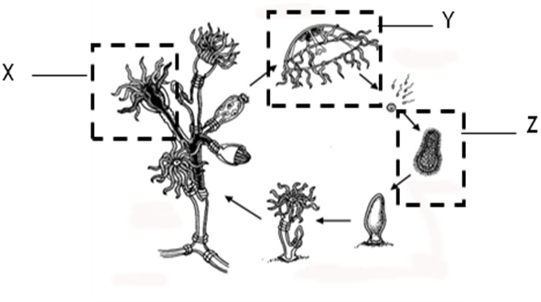  FIGURE 1
(a) | What is meant by polymorphism?  [1 mark]
(b) | Name the structure X, Y and Z.  [3 marks]  X :  Y :  Z :
(c) | Briefly describe sexual and asexual reproduction in Obelia.  [2 marks]
(d) | State the structural difference between reproductive and feeding polyp.  [2 marks]
(e) | Give TWO functions of the single opening of gastrovascular cavity in Cnidarians.  [2 marks]
Bil. | Question | Elaboration
2. | TABLE 1 shows paramecium growth when cultured separately.  TABLE 1  TABLE 1
  Days | No. of P.caudatum  (per drop) | No. of P. Aurelia  (per drop)
  0 | 4 | 4
  2 | 10 | 10
  4 | 30 | 46
  6 | 48 | 66
  8 | 58 | 70
  10 | 62 | 69
  12 | 60 | 71
  14 | 61 | 71
  16 | 60 | 71
(a) | Based on the data in TABLE 1, predict the result when the two species are cultured together in a conical flask and the medium is refreshed daily.  [2 marks]
(b)i | Sketch the graph of your result based on your answer in 2(a).  [3 marks]
ii | Explain your answer.  [2 marks]
(c) | What is the limiting factor in this experiment?  [1 mark]
(d)i | State the type of competition:  [2 marks]  - Based on the data in TABLE 1.  - Based on the predicted graph in 2 (b)(i).
Bil. | Question | Elaboration
3. | FIGURE 2 shows the structure of a nephron.  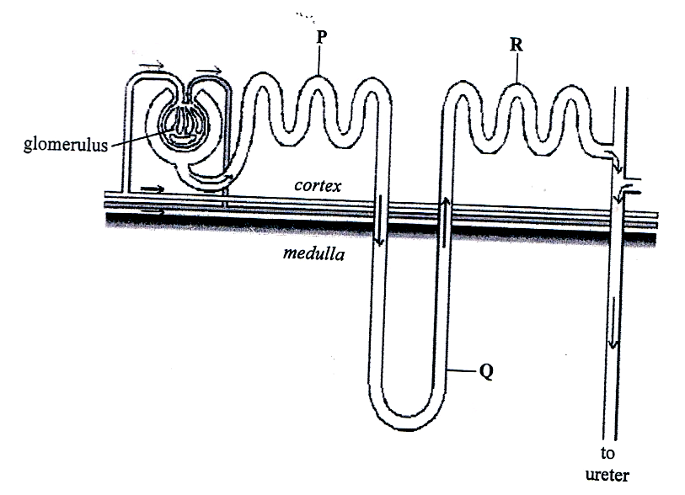  FIGURE 2
(a) | Name P, Q and R.  [3 marks]  P :  Q :  R :
(b) | Which parts reabsorb water into blood vessels?  [1 mark]
(c)i. | Which part plays the most important role in regulating water level in kidney?  [1 mark]
ii. | Give reason for your answer in 3 (c)(i).  [1 mark]
(d)i. | State TWO unique features of P.  [2 marks]
ii. | Give the significant of the features mentioned in 3(d)(i).  [2 marks]
Bil. | Question | Elaboration
4. | 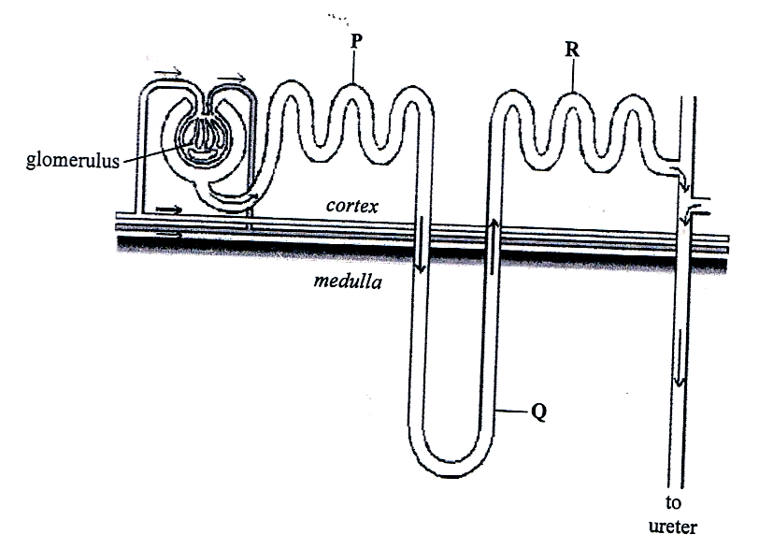  FIGURE 3 shows steps involved in the cloning of human insulin gene.  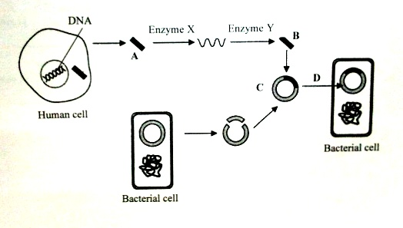  FIGURE 3
(a) | Name molecule A, B and C.  [3 marks]  A :  B :  C :
(b) | Name enzyme X and enzyme Y.  [2 marks]  Enzyme X :  Enzyme Y :
(c) | Why is insulin gene obtained from a rather than the DNA?  [1 mark]
(d) | Name process D.  [1 mark]
(e) | Why does the recombinant plasmid able to replicate autonomously inside the host?  [1 mark]
(f)i. | What is the importance of marker gene at C?  [1 mark]
ii. | Give ONE example of marker gene.  [1 mark]
Bil. | Question | Elaboration
BAHAGIAN B (60 markah)
5. | (a)  i. What are the unique characteristics used to identify Gingkophyta?  [4 marks]  ii. Differentiate morphological characteristics between Coniferophyta and Gnetophyta.  [6 marks]
(b) Describe the classification of animals based on their body cavity formation and gives an example for each class.
[10 marks]

6. | (a) Explain the process in the final stage of cellular respiration occurring in electron transport chain.  [12 marks]
(b) Discuss the similarities and differences between aerobic and anaerobic respirations.
[8 marks]

7. | (a) Describe the mechanism of heart beat in mammals.  [10 marks]
(b) Explain the translocation process in plants.
[10 marks]

Bil. | Question | Elaboration
8. | (a) Explain the functions of the different classes of antibodies.  [10 marks]
 | (b) Discuss the functions of different types of cells that occurred in humoral response.
9. | (a) Explain tools used in recombinant DNA technology.  [10 marks]
(b) Describe the steps involved in gene cloning.
[10 marks]

PSPM 2 SESSION 2012/2013 (ANSWER SCHEME)
Bil. | Question | Elaboration
BAHAGIAN A (40 markah)
1 | Obelia is a type of marine hydroid and its life cycle is shown in FIGURE 1.  FIGURE 1
(a) | What is meant by polymorphism?  [1 mark]  Organism with two or more (different) body form/structure/morphology
(b) | Name the structure X, Y and Z.  [3 marks]  X : feeding polyp  Y : medusa  Z : ciliated planula (larva)
(c) | Briefly describe sexual and asexual reproduction in Obelia.  [2 marks]  Asexual : The blastostyle/reproductive polyp/gonozoid  produces medusa through budding.  Sexual : The sperm from male medusa and ovum from  female medusa combine to form a zygote.
(d) | State the structural difference between reproductive and feeding polyp.  [2 marks]  Repdoductive polyps have medusa buds and feeding polyps has tentacles
Bil. | Question | Elaboration
(e) | Give TWO functions of the single opening of gastrovascular cavity in Cnidarians.  [2 marks]  Mouth/ingestion  Anus/egestion
2. | TABLE 1 shows paramecium growth when cultured separately.  TABLE 1  TABLE 1
  Days | No. of P.caudatum  (per drop) | No. of P. Aurelia  (per drop)
  0 | 4 | 4
  2 | 10 | 10
  4 | 30 | 46
  6 | 48 | 66
  8 | 58 | 70
  10 | 62 | 69
  12 | 60 | 71
  14 | 61 | 71
  16 | 60 | 71
(a) | Based on the data in TABLE 1, predict the result when the two species are cultured together in a conical flask and the medium is refreshed daily.  [2 marks]  The number of P. aurelia increases while number of P. caudatum decreases
(b)i | Sketch the graph of your result based on your answer in 2(a).  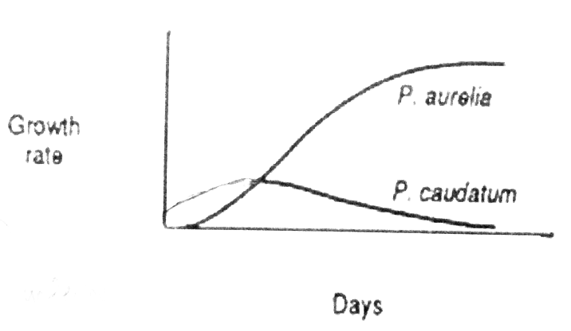  [3 marks]  Correct label for both axes = 1/0  Shape and label of graph = 2/0  Total = 3
Bil. | Question | Elaboration
ii | Explain your answer.  [2 marks]  P. aurelia is more abundant (than P. caudatum)  P. aurelia uses resources more efficiently compared to P. caudatum
(c) | What is the limiting factor in this experiment?  [1 mark]  Space
(d)i | State the type of competition:  [2 marks]  - Based on the data in TABLE 1.  Intraspecific Competition  - Based on the predicted graph in 2 (b)(i).  Interspecific Competition
3. | FIGURE 2 shows the structure of a nephron.  FIGURE 2
(a) | Name P, Q and R.  [3 marks]  P : proximal (convoluted) tubule  Q : (ascending limb) loop of Henle  R : distal (convoluted) tubule
(b) | Which parts reabsorb water into blood vessels?  [1 mark]  Proximal (convoluted) tubule, descending limb of loop of Henle, distal (convoluted) tubule and collecting tubule/duct
Bil. | Question | Elaboration
(c)i. | Which part plays the most important role in regulating water level in kidney?  [1 mark]  Collecting tubule/duct
ii. | Give reason for your answer in 3 (c)(i).  [1 mark]  ADH acts on collecting tubule/duct // has aquaporin channels
(d)i. | State TWO unique features of P.  [2 marks]  - Coiled and lined microvilli  - Contains many mitochondria
ii. | Give the significant of the features mentioned in 3(d)(i).  [2 marks]  (Coiled and microvilli are) to increase surface area for reabsorption processes  (Mitochondria are) to provide energy for active transport
4. | FIGURE 3 shows steps involved in the cloning of human insulin gene.  FIGURE 3
(a) | Name molecule A, B and C.  [3 marks]  A : mRNA  B : cDNA  C : recombinant DNA plasmid/ vector
Bil. | Question | Elaboration
(b) | Name enzyme X and enzyme Y.  [2 marks]  Enzyme X : reverse transcriptase  Enzyme Y : DNA polymerase
(c) | Why is insulin gene obtained from a rather than the DNA?  [1 mark]  DNA contains introns//mRNA contains exon only//  mRNA that has been copied from DNA does not contain any introns//bacteria cannot recognize introns
(d) | Name process D.  [1 mark]  Transformation
(e) | Why does the recombinant plasmid able to replicate autonomously inside the host?  [1 mark]  It contains origin of replication/ ori
(f)i. | What is the importance of marker gene at C?  [1 mark]  For screening/ selection process
ii. | Give ONE example of marker gene.  [1 mark]  lacZ // antibiotic resistence gene/ amp^{R}
BAHAGIAN B (60 markah)
5. | (a)  i. What are the unique characteristics used to identify Gingkophyta?  [4 marks]  - Separate male and female tree// dioecious trees.  - Lateral branch stem consists of secondary xylem.  - Leaves are fan-shaped.  - Female seed coats release unpleasant odour.  - Naked seeds// outer seed coat is fleshy// ovule with three layer of interguments.  - Seeds is cluster.
Bil. | Question |  | Elaboration
- Differentiate morphological characteristics between Coniferophyta and Gnetophyta.
[6 marks]

Coniferophyta | Gnetophyta
All are (woody) trees | Vine, tree, shrubs
Leaves are needle-like | Broad leaves
Their reproductive structures occur in strobili/ cones. | Their reproductive structures occur in strobili that resemble flower.
Xylem consist of tracheids only | Xylem consist of tracheids and vessel elements

(b) Describe the classification of animals based on their body cavity formation and gives an example for each class.
[10 marks]
- Occurs in all triploblastic animals/ consist of three germs layer.
- Acoelomate
- (Acoelomate) is animal without body cavity/ body coelom.
- Example: Platyhelminths/ flatworm/ tapeworm/ fluke.
- Psuedocoelomate
- Psuedocoelomate is an animal with false coelom.
- The cavity of the coelom is not layered by peritoneum tissue// does not completely lined by mesoderm layer.
- The cavity of coelom is not layered by peritoneoum tissue// does not completely lined by mesoderm layer.
- Example: Nematodes/ roundworm/ Ascaris sp.
- Coelomates
- (Coelomate) is an animal with coelom/ true coelom.
- Fluid filled space between the body wall and the digestive system// body cavity is completely lined by mesoderm.
- Example: Annelid/ Mollusc/ Arthropod/ Echinoderm/ Chordate.

6. | (a) Explain the process in the final stage of cellular respiration occurring in electron transport chain.  [12 marks]  - The process known as oxidative phosphorylation.  - Occurs in the inner membrane of mitochondria/ cristae.  - Consist of series of electron carrier// protein complexes NADH dehydrogenase, Ubiquinone/(CoQ/Q), and series of cytochrome/ (cytochrome c reductase, cytochrome c and cytochrome c oxidase) //  - Protein complexes succinate dehydrogenase, Ubiquinone/(CoQ/Q), and series of cytochrome/ (cytochrome c reductase, cytochrome c and cytochrome c oxidase)  - Oxidizing NADH+ H⁺ / FADH₂ // Oxidizing NADH  - As electron is transferred, proton is pumped out from matrix  - into the intermembrane space  - using energy from electron/ redox reaction.  - Cause the accumulation of high concentration of proton/ H⁺ (in the intermembrane space).  - Resulting in H⁺ gradient across the membrane// create proton motive forces.  - The process is called chemiosmosis/ chemiosmosis coupling.  - H⁺/ proton flow back/ diffused into matrix of mitochondria  - through ATP synthase/ chemiosmosis channel/ coupling factor.  - Final electron acceptor is oxygen.  - Water/ H₂O is produced.  - The flow of proton/ H⁺ back into the matrix (provide energy to) generate ATP.  - One molecule of NADH produce 3 ATP and one molecule of FADH₂ produce 2 ATP.
(b) Discuss the similarities and differences between aerobic and anaerobic respirations.
[8 marks]
Similarities
- Both are cellular respiration
- Both involve glycolysis
- Both uses glucose as respiratory substrates

Differences
- Anaerobic respiration does not require oxygen while aerobic respiration require oxygen
- In aerobic repiration, production of ATP by substrate level phosphorylation and oxidative phosphorylation while in anaerobic respiration, production of ATP by substrate level phosphorylation only
- Anaerobic respiration occur in cytoplasm/cytosol only but aerobic respiration occur in cytoplasm/cytosol and mitochondria
- The oxidation of glucose in aerobic respiration is complete but it is partially complete in anaerobic respiration //
- the oxidation of glucose in aerobic respiration involve glycolysis, (link reaction), Krebs cycle and ETC/oxidative phosphorylation while oxidation of glucose in anaerobic respiration involve glycolysis only.
- The products of anaerobic respiration are CO₂, ATP and ethanol // CO₂, ATP and lactate/lactic acid while the products of aerobic respiration are CO₂, ATP and H₂O
- Anaerobic respiration produces 2 ATP while aerobic respiration produces 36/38 ATP.

Bil. | Question |  | Elaboration
7. | (a) Describe the mechanism of heart beat in mammals.  [10 marks]  - Cardiac/ heart muscle is myogenic  - The heart beat starts at sinoatrial node / SAN/ pace maker // SAN generate impulse  - The impulse from pace maker spreads across both atria  - Both atria contract/ atrial systole  - The impulse reach the atrioventricular node/AVN  - The impulse is delayed for 0.1 second after reaching the AVN  - Impulse travels through bundle of His to Purkinje tissues/fibers  - Spreads to all parts of both ventricles  - Both ventricles contracts/ ventricular systole  - Event known as cardiac cycle  - ‘lub’ sound is produced as atrioventricular valve/ AV valves closed  - ‘dub’ sound produced as semilunar valves/ SV valves closed
(b) Explain the translocation process in plants.
[10 marks]
- At the source/leaves
- Companion cells accumulate the sucrose
- Transfer/actively transported the sucrose to the sieve tube
- Through plasmodesmata
- The concentration of sucrose in the sieve tube of a leaf become higher
- The water potential in the sieve tube of a leaf become lower // osmotic pressure in the sieve tube of a leaf become higher
- The water potential in the surrounding tissue/ xylem tissue is higher // osmotic pressure in the surrounding tissue/ xylem tissue is lower
- Water moved from surrounding tissue/ xylem tissue to the sieve tube
- By osmosis ( dependent to point viii)
- Increases the hydrostatic pressure / pressure potential
- Force a mass/bulk flow of water and sucrose in the sieve tube
- To the sink/ fruit/root/ shoot tip/stem
- Which has lower hydrostatic pressure

Bil. | Question |  | Elaboration
8. | (a) Explain the functions of the different classes of antibodies.  [10 marks]
  Class | Function
  Immunoglobulin A / IgA | Prevent bacteria and viruses from attaching to mucus membrane// acts as mucosal antibody// passive immunity for nursing infants// acts as first lined defense
  Immunoglobulin D / IgD | Act as receptors for antigen on B cell surface// involved in the activation of lymphocyte B cells
  Immunoglobulin E / IgE | Involved in hypersensitive reaction that produces allergies// trigger release of histamine from mast cell and basophile // involve in allergy reaction
  Immunoglobulin G / IgG | Acts as marker that stimulate phagocytosis by macrophage// promotes phatocytosis// protects aganist bacteria/virus/toxin // involve in secondary immune response
  Immunoglobulin M / IgM | Acts as receptors on lymphocytes surface//bind many antigen at once//effective in clumping viruses/bacteria// involve in primary immune response
(b) Discuss the functions of different types of cells that occurred in humoral response.
[10 marks]
Type of cell | Function
Plasma cell | Secretes/ form/ produce/ release antibodies
Memory (B) cell | Initiates production of plasma cell when encounter the same bacteria/ antigen in future infection // secondary immune response
Helper T cell / Helper T₄ cell | Activates B cell // secrete interleukin II
Bil. | Question |  | Elaboration
9. | (a) Explain tools used in recombinant DNA technology.  [10 marks]  - Target DNA/ gene/ gene of interest/ DNA donor  - DNA fragment to be cloned/ inserted (into plasmid/vector)  - DNA cloning vector/ plasmid/ bacteriophage/ cosmid/ YAC  - A vehicle/ agent used in gene cloning// carry a foreign DNA fragment into the host cell  - Restriction enzyme/ restriction endonuclease  - Enzyme that recognize specific base sequence of DNA/ / Cut/cleave DNA at specific base sequence/ restriction site  - Modifying/ ligation enzyme/ (T4) DNA ligase  - Joins the gene of interest and vector to form recombinant DNA  - Host cell  - Organism that receives a recombinant DNA plasmid (for cloning purpose) // organism into which recombinant DNA plasmid is transformed.
(b) Describe the steps involved in gene cloning.
[10 marks]
- Isolation/ purification of DNA genomes that contains gene of interest
- Isolation of target DNA/ gene and plasmid/ (cloning) vector
- Cut/ cleave both DNA and plasmid by the same restriction enzymes
- To have (similar/complementary) sticky/blunt ends (for successful combination)
- Target DNA is inserted into plasmid/ (cloning) vector
- Target DNA/gene and plamid/ (cloning) vector are joined by DNA ligase
- To form a recombinant DNA
- The recombinant DNA are transferred into host cell
- By a transformation process
- Recombinant DNA/ plasmid/ cloning vector is amplified in the host cell
- Followed by screening/ selection process/ blue white screening
- To detect host cell containing recombinant DNA
- Positive cell/ white colonies/ colonies containing recombinant DNA is cultured for further use.

