**LAMPIRAN**

**FORMAT SOALAN**

Bold

1 (b) **FIGURE 2** shows structures of polysaccharides.

Tab

0.5

Tab

0.5

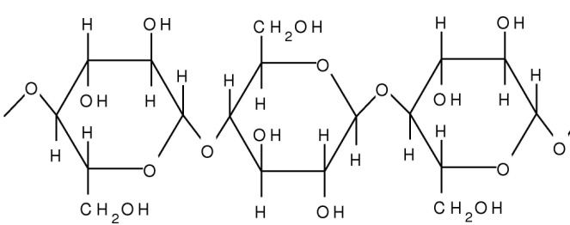

Centre

Tab

0.5

Huruf label Times New Roman: 12 dan Bold

**A**

Center

**FIGURE 2**

**LEVEL 1**

*Italic*

1. Name the monomer and specific bond present in polysaccharide **A**

[2 *marks*]

**________________________________________________________________________________________________________________________**

**LEVEL 2**

Align text right

1. State **TWO** structural differences between polysaccharide A and amylopectin.

[2 *marks*]

____________________________________________________________________________________________________________________________________________________________________________________

**LEVEL 3**

1. Why human intestine unable to digest polysaccharide A?

[1 *mark*]

Line spacing 1.5

________________________________________________________________________________________________________________________