GROUP 1
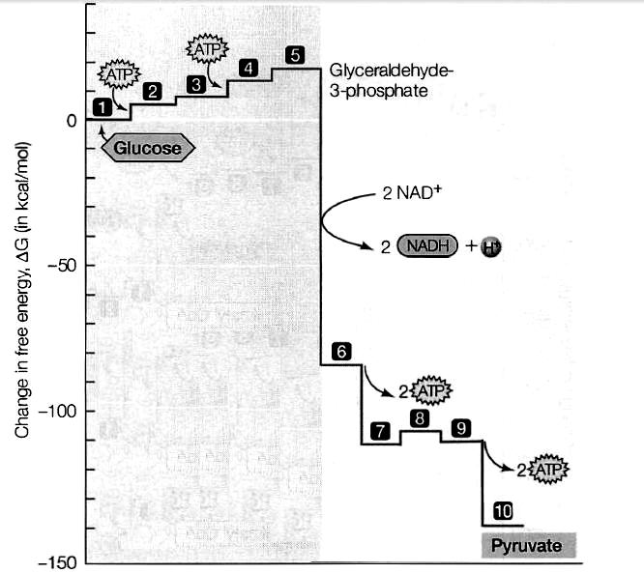
FIGURE 1
GLYCOLYSIS

1. What is glycolysis and where does it take place? ____________________________________
2. Glycolysis begins glucose entering the cell and ends with pyruvate. Note where ATP and NADH
are produced. Identify the other intermediates referring to FIGURE 1.

INTERMEDIATES | ENZYMES | NAME OF PROCESS
Molecule 2: _____________________ | _______________
Molecule 3: _____________________ | _______________
Molecule 4: _____________________
Molecule 5: _____________________
Molecule 6: _____________________
Molecule 7: _____________________
Molecule 8: _____________________
Molecule 9: _____________________
3. State the following phases which involve the formation of the followings:
Molecules 2-5: ______________________ Molecules 6-10: ________________________

GROUP 2
KREBS CYCLE
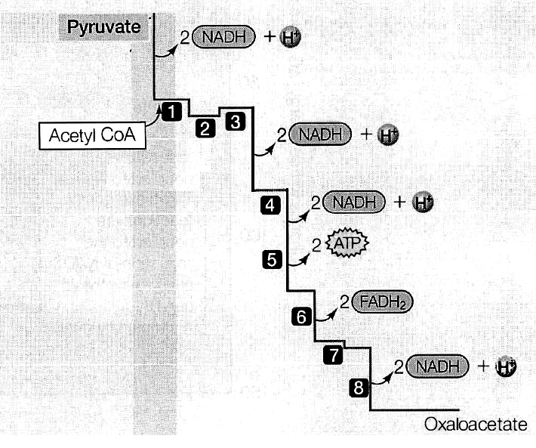
FIGURE 2

1. Where does Krebs cycle take place? ________________________________________________
2. Before Krebs cycle can occur, pyruvate undergoes link reaction. What happens during this
reaction? ______________________________________________________________________

3. FIGURE 2 shows Krebs cycle which involves 8 steps. Note where ATP and NADH are produced.
Identify the following molecules.

MOLECULES | NAME OF PROCESS
1: ____________________________
2: ____________________________
3: ____________________________
4: ____________________________
5: ____________________________
6: ____________________________
7: ____________________________
8: ____________________________
4. Indicate on FIGURE 2 where decarboxylation occurs.
GROUP3
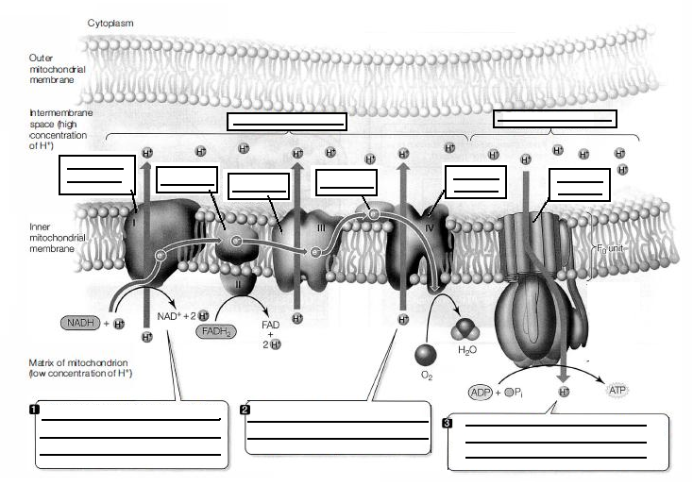
FIGURE 3
OXIDATIVE PHOSPHORYLATION

1. Complete the blanks in FIGURE 3.
2. Complete the concept map in FIGURE 4 which describes oxidative phosphorylation.
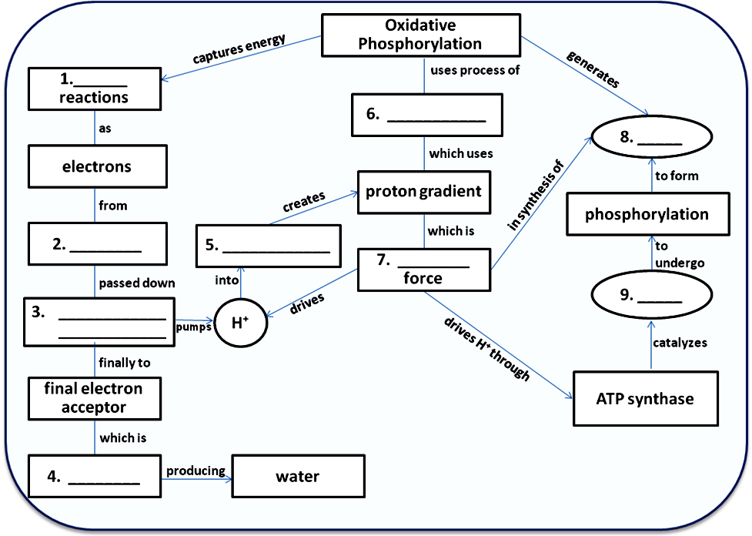

FIGURE 4

GROUP4
ANAEROBIC RESPIRATION

FIGURE 6
- FIGURE 6 shows anaerobic respiration. Complete the diagrams.
- Where does the following occur?
- FIG. 6a: ___________________
- FIG. 6b: ___________________
- How many ATP is produced from ONE molecule of glucose in:
- FIG. 6a: ___________________
- FIG. 6b: ___________________

- How many ATP will be produced if ONE molecule of glucose enters aerobic respiration:
- In ordinary cell: _____________
- In active cells: ______________

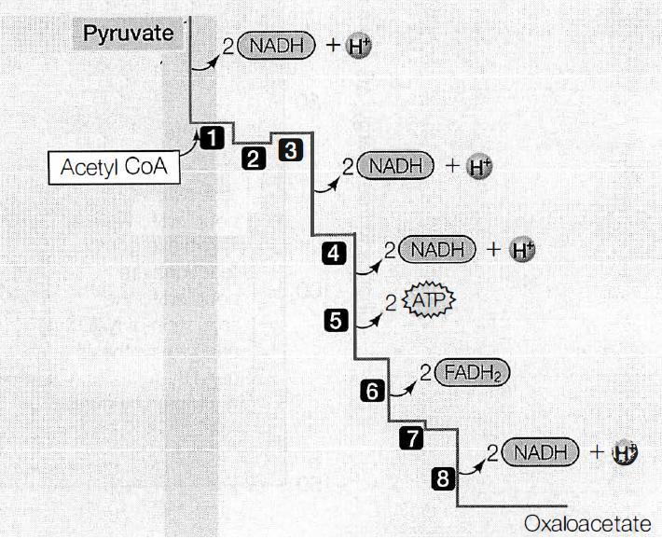

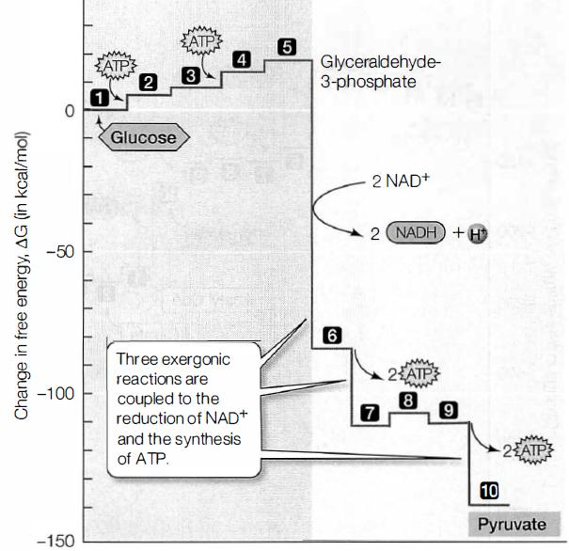

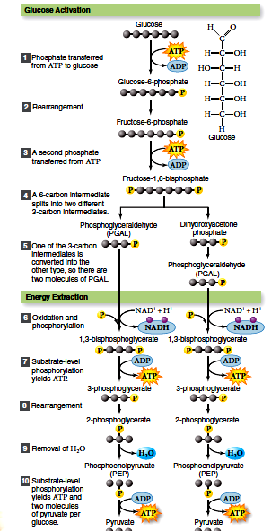
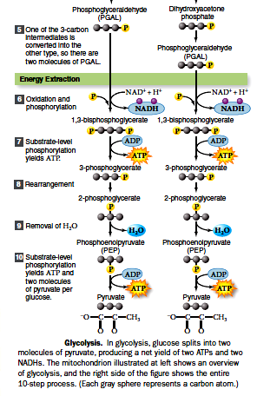
Energy Investment Phase
Energy Harvesting Phase
Glycolysis

