Match Pictures 1

Cashier | Mechanic | Cafe/restaurant
Chef | 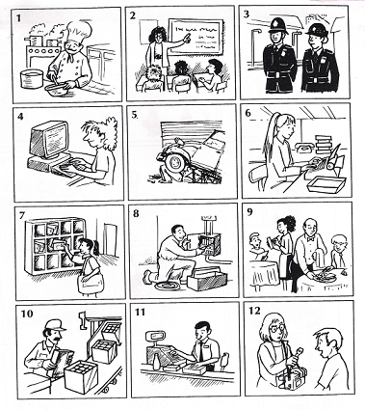  Policeman/policewoman | Company/office
Computer programmer | Postman/postwoman | Factory
Electrician | secretary | Garage
Factory worker | Teacher | School
Journalist | Waiter/waitress | Supermarket

