Using CmapTools

The Views window is the organizational center of CmapTools. From here you can organize your Cmaps and Resources in folders, on your computer's hard drive and on remote servers that are shared with the Cmap community.
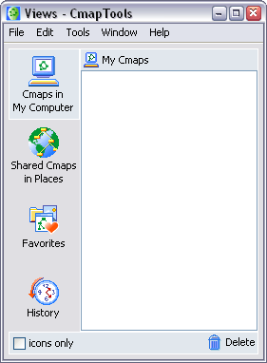
TheViews window contains four main buttons on the left side of the window. Clicking on these buttons will show different locations of Cmaps and Resources in the right side of the window. When CmapTools starts, the Cmaps in My Computer location will be selected.
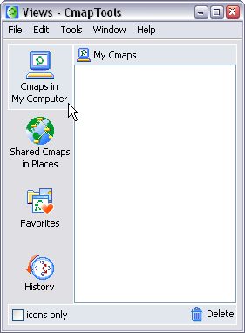
This location contains all of the Cmaps and Resources located on your local computer.
You can create Cmaps here, and later move them to Shared Cmaps in Places at a later time.
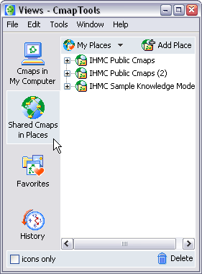
Shared Cmaps are saved to remote Cmap Servers, and are easily viewable, and editable by other CmapTools users around the world. Cmaps saved here are also automatically generated as a web page for anyone with a web browser to see. This is the place to save your Cmaps if you want the rest of the Cmap world to see.
The History button will show a log of Cmaps you've viewed or edited.
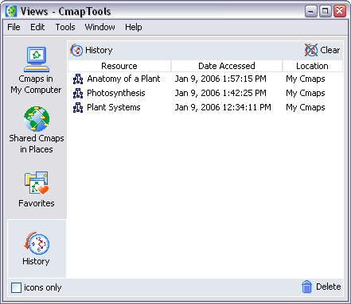
You can clear the history by clicking the Clear button, at the top right of the History list.
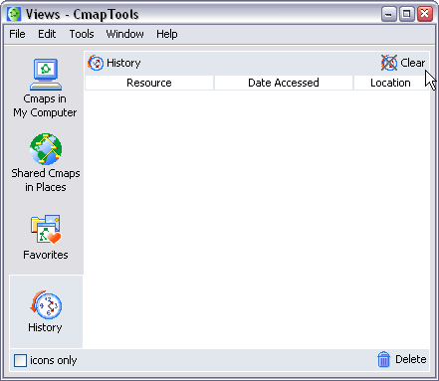

Cmaps and Resources can be added to your list of Favorites. The Favorites button will show the contents of this list.
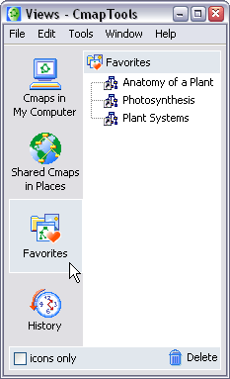
You can add Cmaps and Resources to your Favorites list by selecting the file in the right side of the window, and then clicking Edit then Add to Favorites.
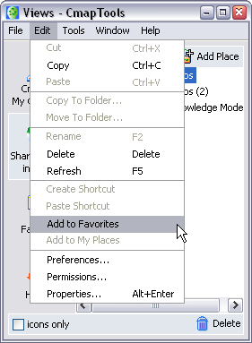

The bottom of the Views window contains two elements of functionality.
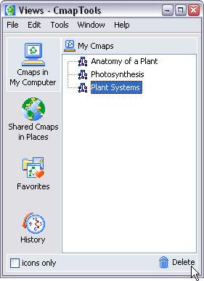
You can quickly delete things by simply dragging them onto the trash can. Beware, this will DELETE the item, you can not recover it once it is dragged to the trash can.
The icons only check box will remove the words from the four main buttons (Favorites, History...) so that there is more room for the content to the right. Use this if you are familiar with the buttons, and don't need to be reminded of what they are.
