Print the Cmap

When printing a Cmap, it is best to first go to the Print Preview.
From an open Cmap:
Select File, then Print Preview...
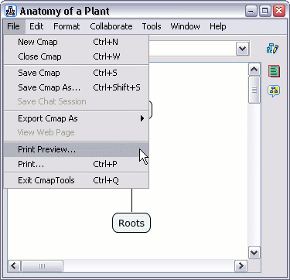
You will now see the Print Preview window. From here, you can choose your page orientation, and set how many pages the Cmap should be printed on, using the Page Layout dialogue.
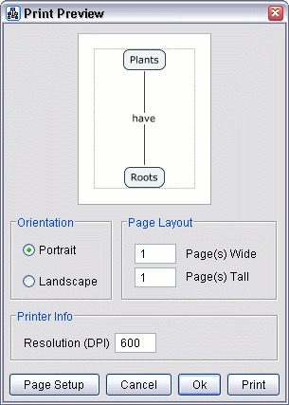
Use the Page Setup button to set additional settings, specific to your printer. If you hit the OK button, the settings will be saved and you can print later, or you can hit the Print button to print immediately.
_____________________________________________________________________________

View Cmap as a Web Page

Cmaps that are saved on CmapServers, are automatically saved with a version that can be viewed as a web page on any web browser.
Once your Cmap is saved to a server, you will see an additional status bar at the bottom of the Cmap, indicating its web address, and showing a button that will allow you to view the web page.
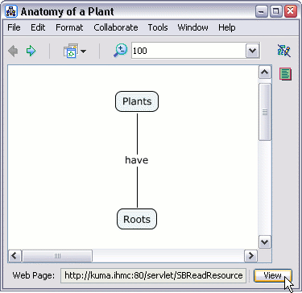
Click the 'View' button, and Cmap Tools will launch your default web browser, and go to the web page version of the Cmap you are viewing.
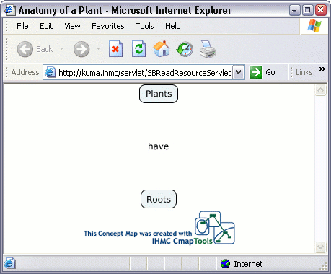
To share this web page with others, simply copy the web address from your web browser and email it as a link to the people you want to see the Cmap as a web page.

