Open a Cmap

From the "Views - CmapTools" window:
Highlight the Cmap that you wish to open. Select File, then Open to have the Cmap open in another window. (Using the left mouse button and double-clicking the title (or icon) of a Cmap, or highlighting its title and pressing Enter, are alternate ways to open a Cmap.)
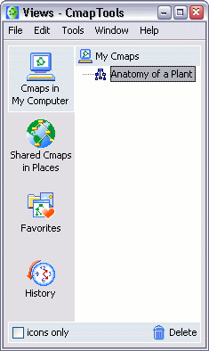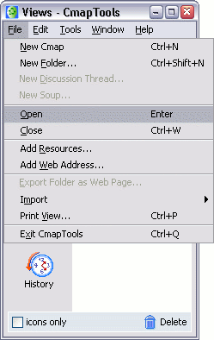

If a Cmap or folder is not highlighted, and either Open is selected from the File menu, or Enter is pressed, the current "View" will open in another window.
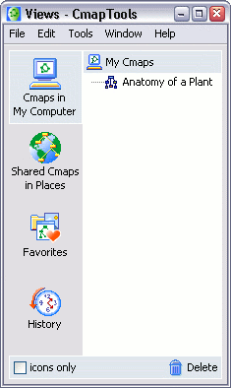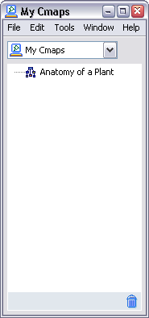

Create a Folder

From the "Views - CmapTools" window:
Click File, then New Folder...
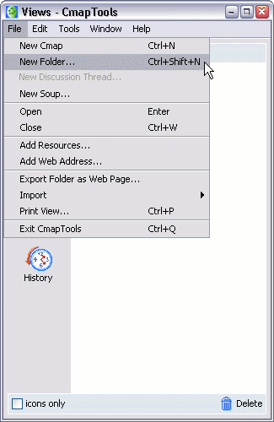
You will now see the New Folder window in which you can enter the Folder Name (required), and other optional attributes for the folder.
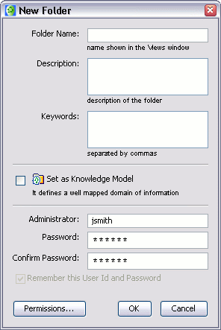
Click the OK button, and the new folder will be created in the Views window. This new folder will be placed in the currently selected directory in the Views window. If no directory is selected, it will be placed at the root of the current view.

